**Training Report**

**on**

**Development of GUI for Vibrational Analysis and PSD Estimation using MATLAB**

**At**



**Terminal Ballistics Research Laboratory (DRDO)**

**Ramgarh**

**Under the supervision of**

**Mrs. Nandini (Scientist – E)**

**Submitted in partial fulfillment for an award of the degree of**

**BACHELOR OF TECHNOLOGY**

**In**

**ElECTRICAL ENGINEERING**



**National Institute of Technology Kurukshetra**

**Submitted by:**

**Harsh Kumar**

**(Roll no: 12114136)**

**CANDIDATE DECLARATION**

I hereby declare that the project work entitled "Development of GUI for Vibrational Analysis and PSD Estimataion Using MATLAB " has been carried out by me under the guidance of Mrs. Nandini (Sc-E) at Terminal Ballistics Research Laboratory (TBRL), Ramgarh,Haryana. This work is submitted in partial fulfillment of the requirements for the award of the degree of Bachelor of Technology in Electrical Engineering at National Institute of Technology (NIT) Kurukshetra.

I affirm that this work is original and has not been submitted previously for the award of any degree or diploma at any other institute or university. All sources of information and data have been duly acknowledged.

Date: June,2024 Harsh Kumar

Place: Ramgarh, Haryana 12114136

**CERTIFICATE**

This is to certify that the project report entitled "Development of GUI for Vibrational Analysis and PSD Estimataion Using MATLAB " submitted by**”** submitted by Harsh Kumar, Roll Number(12114136) in fulfillment of the requirements for the award of the internship certificate in Bachelor of Technology in Electrical Engineering, National Institute of Technology, Kurukshetra, is an authentic and bonafide record of work carried out by him under my supervision and guidance.

To the best of my knowledge, this project report has not been submitted in part or full elsewhere in any other University or Institution for the award of any internship certificate.

Date: May,2023 Supervisor & Mentor

Place: Ramgarh **Mrs.**  **Nandini (Sc-E)**

**ACKNOWLEDGEMENT**

The present work will remain incomplete unless I express my feelings of gratitude towards a number of persons who delightfully co-operated with me in the process of this work.

It is my privilege to thank all the people who have contributed to make this internship period a great and unforgettable experience of my life. First of all, I would like to thank National Institute of Technology, Kurukshetra for providing me the opportunity of gaining practical industry knowledge through internship training at TBRL, DRDO.

I am indebted to my supervisor and mentor Sci. Nandini (Scientist –E) , Mr. Ravinder Singh (Tech. Off. – B) and Proff. Shivam (National Institute of Kurushetra) for their constant encouragement, valuable suggestions, and timely help. Despite their busy schedule and pressure of department work, they always spared time for me, and their able guidance and knowledge kept me on the right track in my work. I am also thankful to the staff in the department of RTRS, TBRL for the general assistance provided during the internship work.

I would also like to express my profound gratitude to all my team members for helping me throughout my training and guiding me whenever I needed any help at any point of time. I am grateful for their cooperation during the period of my internship. The project would not have been possible without the help of many others. I owe regards to them all.

Finally, I would like to acknowledge that this project entitled “Vibrational Analysis and Calculation of PSD using MATLAB” was completed entirely by me and not by someone else.

Harsh Kumar

12114136

**ABSTRACT**

This project presents the development and implementation of a MATLAB GUI application designed for the calculation of G-levels and Power Spectral Density (PSD) of vibration data. The primary goal of this project is to create a user-friendly and efficient interface for analyzing vibration data collected from various sensors. These sensors are mounted on a battery-operated vehicle that traverses a semi-cemented road. The GUI allows users to seamlessly input sensor data, define sampling rates, and specify time intervals for detailed analysis.

In the initial phase, the application processes the input voltage data from the sensors and converts them into G-levels, which are measures of acceleration experienced by the vehicle in the x, y, and z directions. This step is crucial for understanding the magnitude of vibrations impacting the vehicle. The accurate calculation of G-levels provides insight into the dynamic behavior of the vehicle under various conditions and is essential for ensuring safety and performance.

The second phase involves the application of the Welch method to calculate the Power Spectral Density (PSD) of the vibration signals. PSD analysis is performed to transform the time-domain vibration data into the frequency domain, which is critical for identifying the dominant frequencies and understanding the spectral characteristics of the vibrations. The Welch method, known for its ability to reduce noise and provide reliable spectral estimates, is particularly suited for this analysis.

The MATLAB GUI developed in this project is equipped with graphical plotting capabilities that visually represent the time-domain G-levels and the frequency-domain PSD. These graphical representations are essential for providing clear and intuitive insights into the vibration behavior of the vehicle. Users can interact with the GUI to adjust parameters and immediately observe the effects on the computed G-levels and PSD, making it a powerful tool for iterative analysis and testing.

This project significantly enhances the efficiency and accuracy of vibration analysis in automotive testing and other engineering applications. By providing a robust and interactive platform for researchers and engineers, the MATLAB GUI facilitates the interpretation and utilization of vibration data, ultimately contributing to the improvement of vehicle design, performance, and safety. Future work may involve extending the functionality of the GUI to support real-time data acquisition and analysis, integrating additional signal processing techniques, and applying the tool to a broader range of vehicular and structural health monitoring applications.

**Table of Contents**

**CONTENT Page No**

Candidate Declaration i

Acknowledgement ii

About Company iii

Abstract iv

List Of Figures v

**Chapter 1: Introduction**

1.1 About Organisation…………………………………………………………….1

1.2 Brief Overview of Work………………………………………………………10

1.3 Objective………………………………………………………………………10

1.4 Scope ………………………………………………………………………….12

1.5 Projects Requirements…………………………………………………………13

1.5.1 Hardware Requirements…………………………………………………13

1.5.2 Software Requirements……………………………………………….....13

**Chapter 2: Literature Review**

2.1 Data Acquisition System……………………………………………………..14

2.2 Overview of G-levels and Power Spectral Densities (PSD)…………………..16

2.3 Vibrational Analysis…………………………………………………………..19

**Chapter 3: Methodology**

3.1 Description of the Vehicle used and Sensor Setup…………………………….22

3.2 Data Acquisition Process……………………………………………………....23

3.3 Signal Processing Techniques used……………………………………………23

3.4 MATLAB tools and functions used for Data Analysis………………………..24

**Chapter 4: Sensors for Vibration Data Acquisition**

4.1 Types of Sensors………………………………………………………………27

**Chapter 5: GUI Development in MATLAB**

5.1 Overview of the GUI………………………………………………………….35

5.2 Design and Layout…………………………………………………………….36

5.3 Key Features and Functionalities…………………………………………...…38

5.4 MATLAB Code………………………………………………………………..41

**Chapter 6: Data Analysis and Results**

6.1 Plotting G-levels……………………………………………………………….55

6.1.1 Data Preprocessing in MATLAB……………………………………….55

6.1.2 Plotting Techniques in MATLAB………………………………………56

6.1.3 Interpretation of G-levels Plots………………………………………….57

6.2 Power Spectral Densities (PSD) Analysis

6.2.1 PSD Calculation Methods in MATLAB………………………………...58

6.2.2 Plotting PSD in MATLAB………………………………………………63

6.2.3 Interpretation of PSD Plots………………………………………………64

**Chapter 7: Plotted Graphs**

7.1 G-levels Graphs…………………………………………………………………67

7.2 PSD Graphs……………………………………………………………………..69

**Chapter 8: Conclusion**

8.1 Summary of Key Findings………………………………………………………72

8.2 Recommendations for Future Work……………………………………………..73

**LIST OF FIGURES**

Figure 1.1: DRDO logo 1

Figure 1.2: Rail Track Rocket Sled 9

Figure 1.3: Penta Rail Track 10

Figure 3.1:Battery Operated Vehicle 23

Figure 4.1:Capacitive Accelerometer Diagram 27

Figure 4.2: Capacitive Accelerometer Image 28

Figure 4.3: Piezo-resistive Accelerometer 29

Figure 4.4: Piezo-resistive Accelerometer Diagram 29

Figure 4.5: MEMS Accelerometer 31

Figure 4.6: MEMS Accelerometer Image 31

Figure 4.7: Strain Gauge Accelerometer Diagram 32

Figure 4.8: Strain Gauge Accelerometer 33

Figure 4.9: Piezo-electric Acclerometer 34

Figure 4.10: Piezo-electric Acclerometer Diagram 34

Figure 5.1: GUI Layout 40

Figure 7.1: Import Panel of GUI 66

Figure 7.2: Input Sensitivities Panel of GUI 66

Figure 7.3: G-Levels(0-40 sec) 67

Figure 7.4: G-Levels(1-10 sec) 67

Figure 7.5: G-Levels(10-18 sec) 67

Figure 7.6: G-Levels(18-25 sec) 68

Figure 7.7: PSD(0-40) 68

Figure 7.8: GRMS(0-40) 68

Figure 7.9: PSD(1-10 sec) 69

Figure 7.10: GRMS(1-10) 69

Figure 7.11:PSD(10-18 sec) 69

Figure 7.12: GRMS(10-18) 70

Figure 7.13: PSD(18-25 sec) 70

Figure 7.14: GRMS(18-25) 70

**CHAPTER 1**

* 1. **About Organisation**

**1.1.1 Development and Defense Research Organization (DRDO)**



Fig 1.1

The Defence Research and Development Organisation (DRDO) is the principal agency within the Ministry of Defence of the Government of India, entrusted with military research and development, and is based in Delhi, India. The Defence Science Organisation was founded in 1958 by the amalgamation of the Technical Development Establishment and the Directorate of Technical Development and Production of the Indian Ordnance Factories. Following that, in 1979, the Defence Research and Development Service (DRDS) was established as a service of Group 'A' Officers / Scientists directly under the administrative jurisdiction of the Ministry of Defence.

The Defence Research and Development Organisation (DRDO) is the R&D wing of the Ministry of Defence, Government of India, with a vision to empower India with cutting-edge defense technologies and a mission to achieve self-reliance in critical defence technologies and systems, while equipping our armed forces with state-of-the-art weapon systems and equipment in accordance with requirements laid out by the three Services. The DRDO's pursuit of self-reliance and successful indigenous development and production of strategic systems and platforms such as Tejas light combat aircraft have given India's military in research and technology, particularly in military technologies.

**HISTORY**

The Defence Research and Development Organisation (DRDO) was formed in 1958 by the merger of the Indian Army's existing Technical Development Establishments (TDEs) and the Directorate of Technical Development & Production (DTDP) with the Defence Science Organisation (DSO). DRDO was a modest organisation with only ten institutions or laboratories at the time. It has expanded in a variety of ways over the years, including the number of laboratories, achievements, and prominence.

In the 1960s, the DRDO launched initiative Indigo, its first major initiative in surface-to-air missiles (SAM). Indigo was terminated in subsequent years after failing to achieve full success. In the 1970s, Project Indigo and Project Devil collaborated to build short-range SAM and ICBMs. The Prithvi missile was later developed as part of the Integrated Guided Missile Development Programme (IGMDP) in the 1980s. Between the early 1980s and 2007, the Indian Ministry of Defence funded the development of a wide range of missiles, including the Agni missile, Prithvi ballistic missile, Akash missile, Trishul missile, and Nag Missile.

In the 1960s, the DRDO launched initiative Indigo, its first major initiative in surface-to-air missiles (SAM). Indigo was terminated in subsequent years after failing to achieve full success. In the 1970s, Project Indigo and Project Devil collaborated to build short-range SAM and ICBMs. The Prithvi missile was later developed as part of the Integrated Guided Missile Development Programme (IGMDP) in the 1980s. Between the early 1980s and 2007, the Indian Ministry of Defence funded the development of a wide range of missiles, including the Agni missile, Prithvi ballistic missile, Akash missile, Trishul missile, and Nag Missile.

**VISION**

Providing the country with cutting-edge indigenous defense and security technology and systems. The DRDO is determined to make the country strong and self-sufficient in research and technology, particularly in military technologies.

**MISSION**

1. Design and develop cutting-edge sensors, weapon systems, platforms, and allied equipment for the land, air, sea, space, and cyber domains of defense and security.
2. Facilitate the development and implementation of Systems and Technologies developed within the Department's R&D ecosystem.
3. Offer technology solutions to the Services in order to improve combat effectiveness.
4. Collaborate to nurture and strengthen defense R&D competence in Indian industry, science and technology (S&T) institutions, and academia.
5. Infrastructure and test and evaluation facilities development; design certification; skill development and human resource strengthening.

**DRDO LABORATORIES**

1. Aeronautics
   * Aeronautical Development Establishment (ADE), Bangalore
   * Aerial Delivery Research & Development Establishment (ADRDE), Agra
   * Centre for Air Borne Systems (CABS), Bangalore
   * Defence Avionics Research Establishment (DARE), Bangalore
   * Gas Turbine Research Establishment (GTRE), Bangalore
   * Centre for Military Airworthiness & Certification (CEMILAC), Bangalore
2. Armaments
   * Armament Research & Development Establishment (ARDE), Pune
   * Centre for Fire, Explosive & Environment Safety (CFEES), Delhi
   * High Energy Materials Research Laboratory (HEMRL), Pune
   * Proof & Experimental Establishment (PXE), Balasore
3. Combat Vehicle and Engineering
   * Combat Vehicles Research & Development Est. (CVRDE), Chennai
   * Vehicle Research & Development Establishment (VRDE), Ahmednagar
   * Research & Development Establishment (R&DE), Pune.
   * Snow & Avalanche Study Est (SASE), Manali.
4. Electronics and Computer Sciences
   * Advanced Numerical Research & Analysis Group (ANURAG), Hyderabad
   * Center for Artificial Intelligence & Robotics (CAIR), Bangalore
   * DRONA CELL, Delhi
   * Defence Electronics Application Laboratory (DEAL), Dehradun
   * Defence Electronics Research Laboratory (DLRL), Hyderabad
   * Defence Terrain Research Laboratory (DTRL), Delhi
   * Defence Scientific Information & Documentation Centre (DESIDOC), Delhi
   * Instruments Research & Development Establishment (IRDE), Dehradun
   * Laser Science & Technology Centre (LASTEC), Delhi
   * Electronics & Radar Development Establishment (LRDE), Bangalore
5. Human Resource Development
   * Defence Institute of Advanced Technology (Deemed University), Pune
   * Institute of Technology Management (ITM), Mussoorie
6. Life Sciences
   * Defence Agricultural Research Laboratory (DARL), Pithoragarh
   * Defence Bioengineering & Electro Medical Laboratory (DEBEL), Bangalore
   * Defence Food Research Laboratory (DFRL), Mysore
   * Defence Institute of Physiology & Allied Sciences (DIPAS), Delhi
   * Defence Institute of Psychological Research (DIPR), Delhi
   * Defence Research Laboratory (DRL), Tejpur
7. Missiles
   * Terminal Ballistics Research Laboratory (TBRL), Chandigarh
   * Defence Research & Development Laboratory (DRDL), Hyderabad
   * Institute of Systems Studies & Analyses (ISSA), Delhi

**1.1.2 Terminal Ballistics Research Laboratory (TBRL)**

TBRL is a vital DRDO lab located in Chandigarh that is actively involved in the development, production, processing, and characterization of various high explosive compositions, blast, lethality, and fragmentation studies of warheads, shells, and other ammunitions, captive flight testing of bombs, missiles, and airborne systems, ballistics evaluation of various protective systems such as body armor, vehicle armor, and helmets against small arm ammunition, and so on.

Standardization Testing and Quality Certification Services (STQC), Department of Information Technology (DIT), Government of India, has accredited the laboratory to the International Quality Management Systems Standard ISO 9001:2000. In 2014, it was upgraded to ISO 9001:2008.

**HISTORICAL BACKGROUND**

Following the end of World War II, new generation weapons and warheads were introduced into military forces around the world. To keep up with these new technological breakthroughs, there was a great need to establish an indigenous foundation for establishing specialized instrumented facilities and range technologies required for the evolution of data required for the design, development, and assessment of warheads and weapon systems.

Terminal Ballistics Research Laboratory, Chandigarh was established in 1961 as one of the Department of Defence Research & Development armament research laboratories, with the goal of providing facilities for applied research and technology development in the fields of high explosives processing, detonics and shock dynamics, blast & damage, immunity, lethality & fragmentation, defeat of armour, and performance evaluation of warheads & other armament systems.

The Terminal Ballistics Research Laboratory (TBRL) was envisioned in 1961 as one of the Department of Defence Research & Development's new weaponry research institutes.

The laboratory became fully operational in 1967 and was publicly launched by the then-Defense Minister in January 1968. While the main laboratory is located in Chandigarh, the shooting range, which spans 5000 acres, is located 22 kilometres away in Ramgarh, Haryana..

**VISION**

TBRL envisions self-reliance in the development of warhead technologies and provides cutting-edge diagnostics tools for assessing the terminal effects of armaments systems.

**AREA OF WORK**

* Armour performance against bullets and immunity profiles.
* Ground shock, blast damage, fragmentation, and lethality research.
* Making safety templates for various weapons.
* Underwater detonics and pressure wave propagation research.
* Forming, cladding, and welding with explosives.
* Different high explosive compositions are developed, manufactured, processed, and characterised.
* Impact and penetration experiments, as well as material characterization at high strain rates.
* Explosive driven magnetic flux compression technology for producing high energy electrical pulse power.
* Bombs, missiles, and airborne systems are subjected to captive flight testing.
* Ballistics testing of various protective systems against small arm ammunition, such as body armour, vehicle armour, and helmets.
* Design and development of baffle ranges, warheads, and other components.

**MISSION**

* + Create warhead-related technologies and products.
  + Provides cutting-edge diagnostics for testing and evaluating weapons systems
  + Create a strong technology basis in the country for arms by providing the necessary infrastructure and devoted quality workforce.
  + Technologies
  + High energy electrical pulse power generation using explosively induced magnetic flux compression
  + Material dynamic shock compression and detonation wave shaping
  + Shaped charges and EFP technology are being used to defeat armoured and naval targets.
  + Small-arm shooting ranges with baffles
  + Small-arms ammunition for low-intensity warfare
  + Electronic Fuzzes Enabling Technologies

**1.1.3 Rail Track Rocket Sled (RTRS)**

**Historical Background and Establishment:**

The Rail Track Rocket Sled (RTRS) facility has its roots in the defense research and development initiatives of India. Established in 1988 under the auspices of the Defence Research and Development Organisation (DRDO), the facility represents a significant milestone in the country's pursuit of advanced testing capabilities in the aerospace and defense sectors.

The decision to establish the RTRS facility was driven by the growing need for a dedicated testing infrastructure to support the development and evaluation of armament, missile systems, aerospace technologies, and other defense-related projects. As India sought to enhance its indigenous defense capabilities, the establishment of such a facility was deemed crucial for conducting rigorous testing and validation of critical defense systems.

Located at the Terminal Ballistic Research Lab (TBRL) in Haryana, India, the RTRS facility was strategically positioned to benefit from the expertise and resources available within the DRDO network. Over the years, the facility has played a pivotal role in supporting various defense programs and initiatives, contributing to the advancement of national security objectives.

With a rich historical background rooted in India's defense research and development efforts, the RTRS facility continues to serve as a cornerstone of the country's defense testing infrastructure, driving innovation and excellence in the field of aerospace and defense technology.

**Vision:**

To be a leading global provider of advanced rocket sled based high-speed rail track test facilities, facilitating cutting-edge research and development in aerospace, armament, and ballistic systems.

**Mission:**

Our mission is to continuously innovate and refine high-speed sled track testing techniques, providing highly accurate and versatile testing capabilities to meet the evolving needs of development and research in the aerospace and defense sectors. We aim to offer comprehensive facilities and expertise to support the design, testing, and evaluation of a wide range of systems, from aircraft munitions to hypersonic vehicles, enabling our clients to achieve their objectives efficiently and effectively.

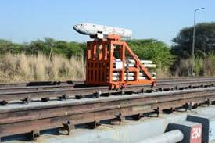

Fig 1.2 Rail Track Rocket Sled

**Rail Track Specifications, Noteworthy Features, and Achievements**

**Specifications:**

* + - The Rail Track Rocket Sled (RTRS) facility features a supersonic penta-rail supporting five rail lines.
    - The track is precision-aligned to ensure accurate testing conditions and withstand high loads.
    - Over the years, the track length has been extended to 4 kilometres.
    - Multiple lines of wider gauges are available on the track to accommodate various payloads.

**Special Points:**

**Precision Alignment**: The track is precision-aligned to ensure accurate testing conditions, contributing to the reliability and effectiveness of testing operations.

**Extended Track Length**: The extension of the track length to 4 kilometres provides ample space for testing operations and accommodates various payloads effectively.

**Supersonic Penta-Rail**: The supersonic penta-rail, supporting five rail lines, enhances the durability and reliability of the facility, ensuring safe and efficient testing operati

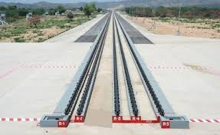

Fig 1.3 Penta-Rail Track

**Achievements:**

**Conducting Numerous Trials**: RTRS has conducted a significant number of trials, encompassing both recovery and non-recovery scenarios, for a diverse array of payloads.

**Impressive Velocity Range**: Achieved velocities ranging from low subsonic to supersonic speeds, with a maximum velocity of Mach 2 in non-recovery trials.

**Contribution to National Defence**: RTRS has played a crucial role in supporting India's defense capabilities by providing essential testing infrastructure for armament, missile systems, aerospace technologies, and other defense-related projects.

**Continuous Progress:** With testing operations conducted year-round, RTRS demonstrates its commitment to meeting the evolving needs of defense research and development, driving continuous progress in the field

**1.2 & 1.3 Brief Overview of work and Objective**

**Objective**: The main goal is to analyse vibration data using Power Spectral Density (PSD) techniques and to provide an interactive interface for users to visualize and interpret the results. This GUI aims to enhance visualization by providing tools for real-time visualization of vibration datasets, enabling users to identify patterns, anomalies, and trends with ease. Additionally, the GUI seeks to facilitate frequency analysis, allowing users to examine spectral characteristics and identify resonant frequencies. Another objective is to enable waveform comparison, aiding in the detection of changes or abnormalities over time. To ensure accuracy, the GUI will utilize advanced algorithms and signal processing techniques. Scalability is also a key consideration, with the GUI designed to manage large datasets and complex analysis tasks effectively. Security measures will be implemented to safeguard sensitive data and ensure compliance with industry standards. The objective is to enhance productivity for engineers and researchers by providing them with a versatile and efficient tool for analysing vibration data.

**Key Components**

1. **Vibration Data Acquisition:**
   * Use accelerometers or other vibration sensors to collect vibration data from machinery or structures**.**
   * Store the acquired data in a suitable format (e.g., .XLSX ,CSV, MAT files).
2. **Power Spectral Density (PSD) Analysis:**
   * PSD is used to identify the dominant frequencies and energy distribution in the vibration signal.
   * MATLAB functions like p-welch can be used for calculating PSD**.**
3. **Graphical User Interface (GUI) Development:**
   * Create a user-friendly interface in MATLAB using the App Designer or GUIDE.
   * The GUI allows users to load data, perform PSD analysis, and visualize results.

**Steps Involved**

1. **Data Acquisition and Preprocessing:**
   * Collect vibration data using sensors.
   * Preprocess the data (e.g., filtering, detrending) to remove noise and prepare it for analysis**.**
2. **PSD Calculation:**
   * Load the vibration data into MATLAB.
   * Use MATLAB’s p-welch function or other relevant functions to compute the PSD of the vibration signal.
   * p-welch syntax example: [pxx,f] = p-welch(x, window, noverlap, nfft, fs);
     + x: Vibration signal.
     + window: Windowing function.
     + noverlap: Number of overlapping samples.
     + nfft: Number of FFT points.
     + fs: Sampling frequency.
3. **GUI Design and Implementation:**
   * Design the GUI layout with components like buttons, axes for plots, and file selection dialogs.
   * Implement callbacks for user interactions, such as loading data, starting the analysis, and displaying results.
   * Use the uifigure, uibutton, uiaxes, and other UI components to build the interface.
4. **Visualization and Interpretation:**
   * Plot the PSD results on the GUI axes for visualization.
   * Highlight significant frequencies and energy distribution in the vibration signal.
   * Provide options for users to zoom, pan, and interact with the plots.

**1.3 Scope**

The scope of a GUI for vibration analysis encompasses essential functionalities such as real-time data visualization, frequency analysis, and waveform comparison. Its primary objective is to provide engineers and researchers with an intuitive interface that simplifies the complex process of interpreting vibration data. Designed to cater to industries like mechanical engineering and structural health monitoring, the GUI aims to streamline tasks related to predictive maintenance and industrial machinery diagnostics. Moreover, it ensures usability by offering an intuitive layout and interactive elements for seamless navigation. Additionally, the GUI's scope extends to scalability, adapting to evolving technological advancements and changing user requirements over time. By addressing these aspects, the GUI serves as a versatile tool for analyzing vibration data, enhancing productivity, and facilitating informed decision-making in various engineering applications.

**1.4 Project Requirements**

**Hardware Requirements**

1. **Computer:**
   * Processor: A modern multi-core processor (Intel i5 or equivalent, preferably i7 or higher).
   * RAM: At least 8 GB of RAM (16 GB or more is recommended for large datasets and smoother performance).
   * Storage: SSD with sufficient space for data storage and MATLAB installation (at least 20 GB free space).
   * Graphics: A dedicated graphics card is not essential but can help with rendering complex plots and figures.
2. **Data Acquisition Hardware:**
   * Vibration Sensors: Accelerometers or other suitable vibration sensors to collect vibration data.
   * Data Acquisition System: A compatible DAQ device or system to interface with the sensors and collect data.
   * Cabling and Connectors: Proper cabling to connect sensors to the DAQ

**Software Requirements**

**1. Operating System**:

* + Compatible with MATLAB (Windows, macOS, or Linux).

**2. MATLAB**:

* + **MATLAB Software**: A licensed version of MATLAB.
  + **Toolboxes**: Signal Processing Toolbox, Instrument Control Toolbox (if using DAQ hardware).
  + **MATLAB App Designer or GUIDE**: For creating the GUI.

**Chapter-2**

**Literature Review**

The study of vibration analysis has been a cornerstone in various engineering disciplines, particularly in mechanical engineering, structural health monitoring, and predictive maintenance. Historically, vibration analysis was performed manually, requiring significant expertise to interpret data accurately. This manual approach often resulted in lengthy analysis times and a higher potential for human error. As technology has advanced, the introduction of software tools and automated systems has revolutionized vibration analysis, making it more efficient and accurate.

In recent years, the development of graphical user interfaces (GUIs) has played a significant role in enhancing the usability of these software tools. GUIs simplify the interaction between the user and the software, allowing for more intuitive data input, manipulation, and visualization

**2.1 Data Acquisition System**A Data Acquisition (DAQ) system for obtaining vibration data from vehicles involves several components and steps to ensure accurate and reliable data collection. Here's an overview of the components and the process**:**

**Components of the DAQ System**

1. **Sensors:**
   * **Accelerometers:** The primary sensors used for measuring vibration. They convert mechanical vibrations into electrical signals.
     + **Types**: Piezoelectric, capacitive, MEMS (Micro-Electro-Mechanical Systems) accelerometers**.**
     + **Mounting**: Securely attached to various parts of the vehicle (e.g., engine, chassis, suspension) to measure vibrations in different axes (x, y, z).
2. **Signal Conditioning:**
   * **Amplifiers**: Boost the low-level signals from the accelerometers to a higher voltage level suitable for digitization.
   * **Filters**: Remove noise and unwanted frequency components from the signal.
3. **Data Acquisition Hardware:**
   * **DAQ Device:** Interfaces with the sensors and digitizes the analog signals into digital data that can be processed by a computer.
     + **Specifications**: High sampling rate (to capture high-frequency vibrations), multiple channels (to collect data from multiple sensors simultaneously), high resolution (for precise measurements).
4. **Data Storage and Processing:**
   * **Computer or Embedded System**: Receives and stores the digital data from the DAQ device.
   * **Software**: MATLAB, LabVIEW, or custom software for data visualization, analysis, and storage.
5. **Power Supply:**
   * **Battery or External Power**: Powers the sensors, signal conditioning equipment, and DAQ device, especially in a mobile vehicle environment**.**

**Steps in the DAQ Process**

1. **System Setup:**
   * **Sensor Placement**: Determine critical locations on the vehicle where vibration measurements are needed (e.g., engine mounts, chassis, suspension).
   * **Mounting**: Securely mount accelerometers to avoid loose connections or movement that can introduce errors**.**
2. **Calibration:**
   * **Sensor Calibration**: Calibrate accelerometers to ensure accurate measurements. This can involve using a known vibration source and adjusting the sensor response.
3. **Signal Conditioning:**
   * **Amplification and Filtering**: Use amplifiers to boost the sensor signals and filters to remove noise and unwanted frequency components.
4. **Data Acquisition:**
   * **Sampling**: Configure the DAQ device for appropriate sampling rates. Higher sampling rates are needed to capture higher-frequency vibrations accurately.
   * **Digitization**: The DAQ device converts the conditioned analog signals into digital data.
5. **Data Storage:**
   * **Real-time Storage**: Store data in real-time on a computer or embedded system for further analysis.
   * **Format**: Save data in a structured format (e.g., CSV, binary files) for easy access and processing**.**
6. **Data Analysis:**
   * **Software Tools**: Use MATLAB or other software tools for analyzing the vibration data. This includes time-domain analysis, frequency-domain analysis (e.g., FFT, PSD), and statistical analysis.
   * **Visualization**: Plot vibration signals, PSD, and other relevant metrics to identify patterns, anomalies, and insights

**2.2 Overview of G-levels and Power Spectral Density (PSD)**

G-levels in vibration analysis refer to the measurement of acceleration due to vibration in terms of the acceleration due to gravity, denoted by "g" where 1g is equivalent to 9.81 m/s². This unit is commonly used to express the intensity o High g-levels indicate strong vibrations that might be harmful to equipment or structures, while low g-levels indicate mild vibrations that are typically within acceptable limits. Monitoring g-levels is crucial for assessing the health and performance of machinery, detecting faults, and preventing failures. In various industries such as automotive, aerospace, manufacturing, and civil engineering, g-levels help analyze vibrations in vehicles, ensure component durability, monitor machinery for predictive maintenance, and evaluate the impact of vibrations on buildings and infrastructure. Data is collected using accelerometers, and the acceleration data, often in m/s², is converted to g-levels by dividing by 9.81 m/s². Analyzing g-levels involves time-domain analysis to identify vibration patterns and frequency-domain analysis to determine dominant frequencies. Setting thresholds for acceptable g-levels based on industry standards and equipment specifications helps in triggering alerts when vibrations exceed safe limits. For instance, an acceleration of 19.62 m/s² corresponds to 2g. In MATLAB, this conversion and visualization can be easily performed, aiding in the clear interpretation of vibration data for further analysis and decision-making. G-levels thus provide a standardized metric for quantifying and assessing vibrations, ensuring the reliability and safety of various systems and structures.f vibrations and can be measured in multiples or fractions of g (e.g., 0.5g, 2g).

Measuring g-levels involves using accelerometers to capture acceleration data and then converting this data into g units. Here’s a step-by-step guide on how to measure g-levels:

**1. Selection of Equipment**

**Accelerometers**:

* **Types**: Piezoelectric, capacitive, MEMS (Micro-Electro-Mechanical Systems) accelerometers.
* **Specifications**: Choose based on the required sensitivity, range, and frequency response.

**Data Acquisition System**:

* A DAQ device or system to interface with the accelerometers.
* Ensure it has the necessary channels and sampling rate to capture the required data.

**Signal Conditioning**:

* Amplifiers to boost low-level signals from accelerometers.
* Filters to remove noise from the signals.

**2. System Setup**

**Mounting Accelerometers**:

* Securely attach accelerometers to the measurement points on the machinery or structure.
* Ensure firm mounting to avoid loose connections or additional noise.

**Connections**:

* Connect accelerometers to the DAQ device through appropriate signal conditioning equipment.

**3. Calibration**

* **Calibrate accelerometers**: Calibration ensures accurate measurements by comparing the accelerometer's output to a known reference.
* **Zeroing**: Ensure the accelerometer reads zero when there is no movement to account for any offsets.

**4. Data Acquisition**

**Configuration**:

* Set up the DAQ device with the appropriate sampling rate (e.g., 1 kHz to 10 kHz depending on the vibration frequency range of interest).
* Configure channels to read the output from the accelerometers.

**Data Collection**:

* Start data acquisition to collect acceleration data over a period of time.
* Ensure the data is saved in a suitable format for analysis (e.g., CSV, MAT files).

**Power Spectral Density (PSD)** is a critical tool in signal processing that quantifies how the power of a signal is distributed across different frequency components. It is used to analyze the frequency content of signals, particularly useful in fields like vibration analysis, telecommunications, and audio engineering. PSD provides insight into which frequencies contain significant power, helping identify dominant frequencies and noise characteristics within a signal. Typically, PSD is estimated using methods such as the Fast Fourier Transform (FFT) and the Welch method, which involve dividing the signal into overlapping segments, applying a window function, and averaging the squared magnitudes of their Fourier transforms. By plotting PSD, engineers and analysts can visually inspect and interpret the distribution of signal power over frequency, facilitating tasks such as identifying resonant frequencies, diagnosing system faults, and designing filters. This analysis is crucial for ensuring the optimal performance and reliability of systems in various applications.

**2.3 Vibrational Analysis**

2.3: Introduction

2.3.1 Overview of Vibration Analysis

* Vibration analysis is a multifaceted discipline within engineering that deals with the study of oscillatory motion in mechanical systems. It encompasses the measurement, analysis, and interpretation of vibrations generated by various sources, including rotating machinery, engines, vehicles, and structural elements. These vibrations can manifest in different forms, such as translational, rotational, or complex motion patterns, and can have significant implications for the performance, safety, and reliability of systems.
* In industrial settings, understanding and managing vibrations are crucial for ensuring the smooth operation of machinery and equipment. Vibrations can arise from a myriad of factors, including mechanical imbalances, misalignments, bearing defects, gear faults, resonances, and external forces such as wind or seismic activity. Left unaddressed, excessive vibrations can lead to accelerated wear and tear, increased energy consumption, reduced product quality, and even catastrophic failures, posing serious risks to personnel safety and business continuity.
* The Vibration Analyzer software stands as a sophisticated tool designed to address the challenges associated with vibration analysis. By leveraging advanced algorithms and visualization techniques, the software empowers engineers, researchers, and analysts to delve deep into the dynamics of mechanical systems, identify potential issues, and devise effective mitigation strategies. From routine maintenance tasks to complex fault diagnosis and troubleshooting, the Vibration Analyzer offers a comprehensive suite of features to support a wide range of vibration analysis tasks.

2.3.2 Importance of Vibration Analysis

* The importance of vibration analysis cannot be overstated in the realm of engineering and industrial applications. Uncontrolled vibrations pose significant risks and challenges across various domains, making the systematic analysis and management of vibrations imperative for operational efficiency and safety.
* Predictive Maintenance: Vibration analysis forms the cornerstone of predictive maintenance strategies, allowing organizations to move away from reactive, time-based maintenance schedules to proactive, condition-based approaches. By continuously monitoring vibration levels and trends, engineers can detect early signs of machinery degradation, predict potential failures, and schedule maintenance interventions at optimal times, thereby minimizing downtime, reducing maintenance costs, and extending equipment lifespan.
* Fault Detection and Diagnosis: Vibrations serve as valuable diagnostic signals, offering insights into the health and condition of machinery and structural elements. By analysing vibration signatures, engineers can pinpoint the root causes of faults and anomalies, such as bearing defects, shaft misalignments, gear tooth damage, and resonance conditions. This enables targeted troubleshooting and corrective actions to be taken, preventing catastrophic failures and preserving asset integrity.
* Structural Health Monitoring (SHM): Beyond machinery, vibration analysis plays a crucial role in monitoring the health and integrity of civil infrastructure, including bridges, buildings, dams, and pipelines. By deploying sensors to monitor vibrations in real-time, engineers can assess structural performance, detect structural defects or damage, and ensure compliance with safety regulations and design standards. SHM systems provide early warnings of potential structural failures, allowing for timely maintenance and repairs to be carried out, thereby safeguarding public safety and minimizing the risk of infrastructure collapses.
* Operational Optimization: Vibration analysis also offers opportunities for operational optimization and performance enhancement. By understanding the vibrational behavior of systems, engineers can identify opportunities to reduce energy consumption, optimize machine settings, improve product quality, and enhance overall system efficiency. Whether it involves fine-tuning control parameters, redesigning components for better damping characteristics, or implementing vibration isolation measures, the insights gained from vibration analysis enable organizations to achieve higher levels of operational excellence and competitiveness.
* In essence, vibration analysis serves as a cornerstone of modern engineering practice, offering invaluable insights into the dynamic behaviour of mechanical systems and structures. The Vibration Analyzer software, with its advanced capabilities and user-friendly interface, empowers engineers and analysts to harness the power of vibration analysis, enabling them to optimize performance, ensure safety, and drive innovation across diverse industrial sectors.

**Chapter-3**

**3.1 Description of the Vehicle used and Sensor Setup**

**Vehicle Description**: The vehicle used in this vibration analysis project is a battery-operated vehicle. This type of vehicle is powered by electric batteries and offers a clean and efficient means of transportation, which is increasingly popular in modern mobility solutions. The battery-operated vehicle typically features electric motors, a battery pack, and electronic control systems that manage the vehicle's performance and energy consumption.

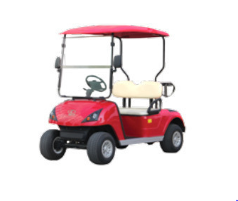

Fig 3.1- Battery Operated Vehicle

**Sensor Setup**: For the purpose of this analysis, accelerometers were mounted on the wheels of the vehicle to capture vibration data. The sensors were strategically placed to ensure accurate measurement of vibrations transmitted through the wheels as the vehicle moved.

* **Accelerometers**: These sensors are designed to measure acceleration forces and were used to detect the vibrations experienced by the wheels. Typically, triaxial accelerometers were employed to capture vibrations in three dimensions (x, y, and z axes), providing a comprehensive view of the vibrational forces at play.
* **Mounting**: The accelerometers were securely attached to the wheels to ensure stable and precise data collection. Proper mounting is crucial to avoid additional noise or erroneous data due to sensor movement or loose connections.

**Road Conditions**: The vehicle was driven on a semi-cemented road, which provides a varied surface texture and introduces different types of vibrational inputs to the vehicle. Semi-cemented roads are characterized by a mix of cement and other materials, often resulting in an uneven and rough surface. This type of road is ideal for vibration analysis as it subjects the vehicle to realistic and challenging conditions that reveal valuable insights into its vibrational behaviour and structural integrity.

**3.2 Data Acquisition Process**

The data acquisition process for obtaining vibration data from a vehicle involves several critical steps to ensure accurate and reliable measurements. Firstly, triaxial accelerometers are securely mounted on the vehicle's wheels, ensuring stable attachment to capture vibrations in all three dimensions (x, y, and z axes). The vehicle, a battery-operated model, is then driven on a semi-cemented road, providing a varied surface texture that introduces realistic vibrational inputs. The accelerometers convert the mechanical vibrations into electrical signals, which are then conditioned using amplifiers to boost the signal and filters to remove noise. These conditioned signals are fed into a Data Acquisition (DAQ) system, which digitizes the analog signals for further analysis. The DAQ system is configured with an appropriate sampling rate to capture the high-frequency components of the vibrations accurately. As the vehicle moves, the DAQ system continuously records the vibration data over a specified duration. This data is then stored in a suitable format, such as CSV or MAT files, for subsequent analysis. Using software tools like MATLAB, the recorded data is processed to convert the acceleration measurements into g-levels and to perform frequency-domain analysis using techniques such as Power Spectral Density (PSD) estimation. This analysis helps identify dominant frequencies and other vibrational characteristics of the vehicle, providing valuable insights into its structural health and performance under different road conditions.

**3.3 Signal processing techniques usedTop of Form**

In the context of obtaining vibration data from a vehicle, several signal processing techniques are employed to ensure accurate analysis and meaningful insights. Initially, the raw acceleration data collected by the accelerometers is pre-processed to remove any noise or unwanted components, using filters such as low-pass, high-pass, or band-pass filters, depending on the specific requirements. Following noise reduction, the data is converted from the time domain to the frequency domain using the Fast Fourier Transform (FFT). This transformation allows for theof dominant frequencies and helps in understanding the spectral content of the vibration signal. Additionally, Power Spectral Density (PSD) estimation is performed to quantify how the power of the vibration signal is distributed across different frequencies. Techniques like Welch's method, which involves segmenting the data, applying a window function, and averaging the squared magnitudes of the Fourier transforms of these segments, are commonly used to obtain a more reliable PSD estimate. These frequency-domain analyses are crucial for identifying resonant frequencies, potential faults, and overall vibrational behaviour of the vehicle. Furthermore, time-domain analysis may also be conducted to observe the variations in vibration intensity over time and to identify transient events or anomalies. By applying these signal processing techniques, the vibration data is thoroughly analysed, providing comprehensive insights into the vehicle's performance and structural integrity

**3.4 MATLAB Tools and Functions used**

In MATLAB, various tools and functions are utilized for analysing vibration data from vehicles, specifically within the Signal Processing Toolbox. This includes filtering techniques such as low-pass, high-pass, and band-pass filters, which are applied to remove noise and unwanted components from the raw acceleration data. The Fast Fourier Transform (FFT) is used to convert the time-domain data into the frequency domain, revealing the dominant frequencies and their amplitudes. Power Spectral Density (PSD) estimation, often performed using Welch's method, quantifies how the power of the vibration signal is distributed across different frequencies, providing a smoother and more reliable estimate. Windowing functions like Hamming, Hann, or Blackman are used to minimize spectral leakage during the FFT process. Additionally, time-domain analysis techniques, such as calculating the Root Mean Square (RMS) value and peak detection, are employed to observe variations in vibration intensity over time and identify transient events or anomalies. Key MATLAB functions for these processes include filter, filtfilt, fft, psd, pwelch, rms, and findpeaks, along with data visualization functions like plot and apps like the Signal Analyzer. These tools enable comprehensive analysis of the vibration characteristics, aiding in diagnostics and performance assessment of the vehicle. MATLAB App Designer is an integrated development environment that enables users to create professional-quality graphical user interfaces (GUIs) for their MATLAB applications, combining the design and coding of an app into a single environment. It features a drag-and-drop interface for adding and arranging UI components like buttons, sliders, and axes, which simplifies layout design without extensive coding. The integrated code view automatically generates MATLAB code for designed components, allowing direct editing to enhance functionality. With a rich set of UI components, customization options, and support for event handling, users can create complex, interactive interfaces. App Designer integrates with MATLAB’s plotting functions, enabling dynamic plots and visualizations, and facilitates app packaging and sharing, including deployment as standalone executables. A typical workflow involves designing the app layout, configuring UI components, adding code for interactivity, implementing data analysis processes such as loading and processing vibration data, testing the app, and packaging it for distribution. This environment is essential for developing sophisticated apps, like a simple vibration analysis app that loads data, applies signal processing techniques, and visualizes results, thereby enhancing data analysis workflows for engineers and scientists.

1. **Reading and Preparing Data**: The code starts by reading a table from a file specified in the GUI's **filenameEditField_2** field using **readtable**. It then determines the number of rows in the first column of the table to set up iteration limits. This data likely contains time and voltage measurements from sensors.
2. **Voltage Range Validation and Adjustment**: The code checks if the user-specified lower voltage (**EnterlowervEditField**) is less than or equal to the upper voltage (**EnteruppervEditField**). If this condition is met, the code proceeds to find the closest data points to the specified voltage values:
   * It iterates through the voltage data to find the bounds closest to the specified lower voltage.
   * It compares the absolute differences between the specified lower voltage and the found bounds to set the **EnterlowervEditField** value to the closest bound.
   * A similar process is repeated for the upper voltage.
3. **Data Extraction Based on Voltage Range**: After adjusting the voltage values, the code identifies the rows in the data that correspond to the specified voltage range using **ismembertol**, which finds data points within a specified tolerance:
   * It locates the indices of the lower and upper voltage bounds within the data.
   * Extracts the corresponding time and voltage data for each axis (X, Y, Z) within this range.
4. **Calculation of G Levels**: The voltage data for each axis is converted to G levels by dividing by the sensitivity values specified in the GUI (**SensitivityofxEditField**, **SensitivityofyEditField**, **SensitivityofzEditField**). G levels represent acceleration and are crucial for understanding the intensity of vibrations.
5. **Power Spectral Density (PSD) Calculation**: The code calculates the PSD of the G-level data using Welch's method (**pwelch**). Welch's method involves segmenting the data, applying a window function, and averaging the periodograms. Parameters include:
   * The G-level data.
   * A window size of 2048 samples.
   * Zero overlap between segments.
   * The sampling rate specified in **EntervalueofSamplingrateEditField**.
6. **PSD Integration and RMS Calculation**: For each axis, the code integrates the PSD over a specified frequency range (0 to 2000 Hz) using **trapz**, which numerically integrates the data using the trapezoidal method. The RMS value is then computed by taking the square root of the integrated PSD. This RMS value represents the overall vibration amplitude and is displayed in the GUI (**GRMSXEditField**, **GRMSYEditField**, **GRMSZEditField**).
7. **Plotting PSD Data**: Finally, the code uses **loglog** to plot the PSD data on log-log axes (**UIAxes4**, **UIAxes5**, **UIAxes6**). Log-log plots are effective for visualizing data across wide frequency ranges and highlighting variations in PSD.

If the initial condition (lower voltage <= upper voltage) is not met, the code handles the case where voltage data might be in descending order or where maximum values are considered:

* It adjusts the lower and upper voltage bounds similarly to the ascending case.
* Extracts time and voltage data accordingly.
* Computes G levels and PSD for the adjusted voltage range.
* Integrates the PSD and calculates RMS values.
* Plots the data.

This comprehensive functionality ensures robust handling of voltage data ranges, accurate calculation of G levels and PSD, and effective visualization, making it a powerful tool for vibration analysis within the MATLAB GUI framework.

**Chapter-4**

**Types of Sensors**

**4.1 Accelerometers**

Acceleration sensors or accelerometers let you make precise measurements of vibration or shock for a variety of applications. Our accelerometers are based on several different technologies and include piezoelectric, strain gauges, MEMS, and capacitive sensors. All sensors are highly resistant against shock and vibration and are suitable for a wide range of purposes. They operate at frequencies of up to 25,000 Hz, with measurement ranges between ±0.25 g and ±70,000 g, and can be deployed in temperatures ranging from -40°C to +140°C. Accelerometers are devices that measure the vibration, or acceleration of motion of a structure.

They have a transducer that converts mechanical force caused by vibration or a change in motion, into an electrical current using the piezoelectric effect.

**4.1.1 DC Accelerometers**

The DC Response Accelerometers are designed to measure low-frequency vibration down to DC. The gas-damped sensing element offers a wide dynamic range and very stable frequency response even after subjection to high shock levels. The accelerometer has built- in conditioning, where the sensing element and electronics are shielded, sealed and insulated from housing.   
DC accelerometers, also known as direct current accelerometers, are used to measure static acceleration forces like gravity or slow-moving dynamic accelerations. They are capable of measuring acceleration down to zero frequency (DC). Here are the main types of DC accelerometers:

* + - 1. **Capacitive Accelerometer**

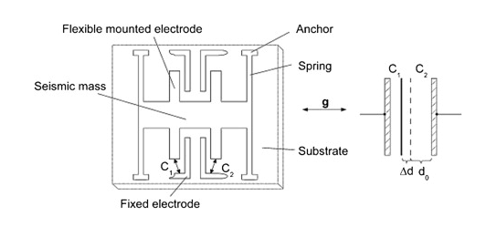

**Fig 4.1- Capacitive Accelerometer Diagram**

**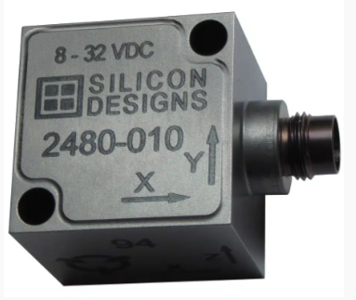  
Fig 4.2-Capacitive Accelerometer Image**

* A capacitive DC accelerometer, also known as a vibration sensor, measures acceleration by detecting changes in electrical capacitance. It's made up of two capacitors, one with a movable electrode connected to a proof mass, and the other with two fixed electrodes attached to the sensor frame. When the proof mass moves, the capacitance between the movable electrode and one of the fixed electrodes increases, while the capacitance of the other capacitor decreases. This change in capacitance is proportional to the acceleration, and a circuit uses this variable to generate a voltage signal that's also proportional to the acceleration. Capacitive accelerometers are the most common type of accelerometer used today, and they're well suited for applications where cost is a factor, like on-board monitoring. They can also measure low-frequency motion and low g levels, such as vibrations in civil engineering. Capacitive accelerometers can operate over a wide temperature range and have low thermal shift and sensitivity shifts.
* **Advantages**: High sensitivity, low noise, and good stability. Suitable for low-frequency applications, including static and quasi-static measurements.

**4.1.1.2 Piezo-Resistive Accelerometers**

A piezoresistive accelerometer produces resistance changes in piezoresistive materials to covert mechanical strain to a DC output voltage. Piezoresistive accelerometers have a very wide bandwidth which allow them to be used for measuring high frequency and high shock events such as crash testing. Piezoresistive accelerometers can be gas or fluid damped which protects the accelerometer; but also, further widens the dynamic range by preventing the accelerometer from reaching its internal resonant frequency.

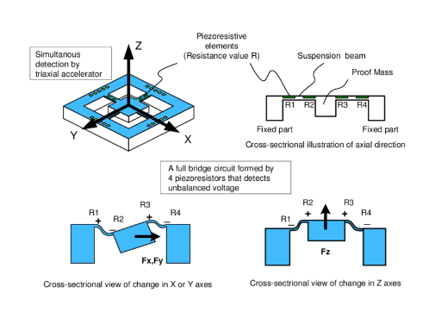

**Fig 4.3-Piezo-resistive Accelerometer**

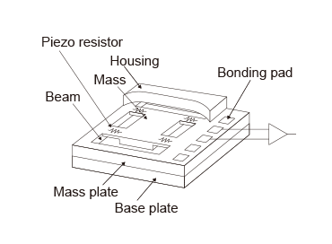

**Fig 4.4-Piezo-resistive Accelerometer diagram**

Piezoresistive accelerometers are by far the best type for impulse/impact measurements where the frequency range and amplitude are typically high; examples include automotive crash testing, automotive safety testing, safety air-bags & traction control system testing and defence weapons testing. DC piezo-resistive accelerometers are a type of accelerometer that leverages the piezo-resistive effect, where the resistance of a material changes under mechanical stress. These accelerometers consist of a seismic mass attached to a piezo-resistive element. When subjected to acceleration, the seismic mass causes deformation of the piezo-resistive element, leading to a change in its electrical resistance. This change is measured and converted into an acceleration value. DC piezo-resistive accelerometers are known for their high-frequency response and good sensitivity, making them capable of accurately measuring both static and dynamic accelerations. They are widely used in applications such as automotive safety testing, where they can measure the rapid deceleration of crash tests, and in industrial vibration monitoring, where they can detect low-frequency vibrations. Their ability to measure static acceleration also makes them suitable for biomedical applications, where precise measurement of slow movements or tilt is necessary. Overall, DC piezo-resistive accelerometers are valued for their robustness, accuracy, and versatility in various demanding environments.

**4.1.1.3 MEMS Accelerometers**

DC MEMS accelerometers are compact, micro-electro-mechanical systems designed to measure acceleration. These accelerometers operate by detecting changes in capacitance or resistance within tiny, micro-machined structures that deform under acceleration. MEMS technology allows for the fabrication of these accelerometers using semiconductor processes, resulting in small, low-cost, and low-power devices. DC MEMS accelerometers can measure static accelerations, such as gravity, and slow dynamic accelerations, making them suitable for a wide range of applications. They are widely used in consumer electronics for functions like screen orientation in smartphones and tablets, in automotive systems for airbag deployment and stability control, and in wearable devices for motion tracking. Their small size and ability to integrate with other electronic components make them highly versatile and essential in modern technology.

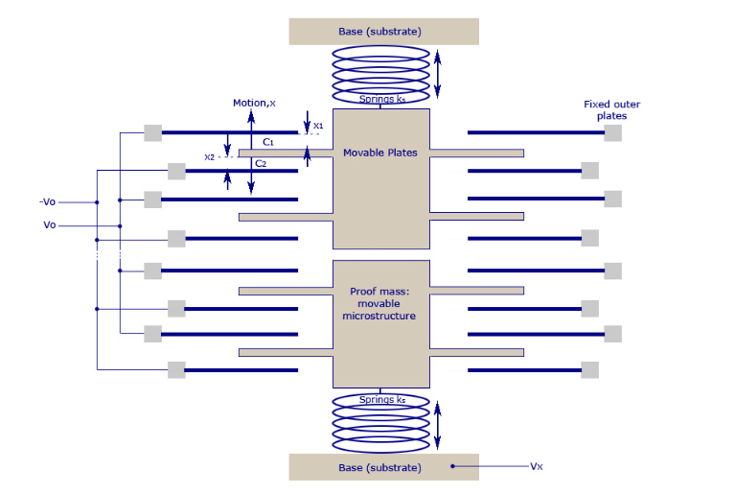

**Fig 4.5-MEMS Accelerometer**

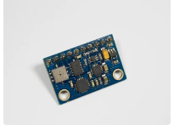

**Fig 4.6-MEMS Accelerometer Image**

**4.1.1.4 Strain Gauge Accelerometers**

DC strain gauge accelerometers measure acceleration by utilizing strain gauges attached to a structure that deforms under acceleration. When the accelerometer experiences acceleration, the deformation of the structure changes the resistance of the strain gauges. This change in resistance is then converted into an electrical signal proportional to the acceleration. DC strain gauge accelerometers are known for their good sensitivity and stability, making them suitable for both static and dynamic acceleration measurements. They are widely used in industrial machinery monitoring to detect vibrations, in automotive testing for crash and safety analysis, and in aerospace applications for monitoring structural integrity. Their ability to accurately measure a wide range of accelerations in various environments makes them versatile and reliable for numerous applications. Strain gauge accelerometers are a type of sensor used to measure acceleration by detecting changes in strain on a material. These accelerometers work on the principle that when a material is deformed, its electrical resistance changes. Strain gauges are typically bonded to a flexible structure within the accelerometer. When the accelerometer experiences acceleration, the structure deforms, causing a change in the electrical resistance of the strain gauges. This change in resistance is proportional to the amount of strain, which can be correlated to the acceleration experienced by the sensor. Strain gauge accelerometers are known for their high accuracy and stability, making them suitable for applications that require precise measurements of low-frequency vibrations and accelerations. They are commonly used in structural monitoring, automotive testing, and other fields where accurate and reliable measurement of acceleration is critical. Additionally, these accelerometers can operate under harsh environmental conditions, making them versatile for a wide range of applications.

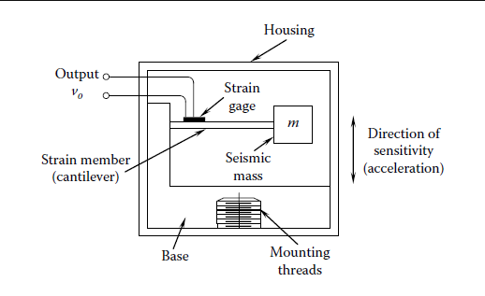

**Fig 4.7- Strain gauge Accelerometer diagram**

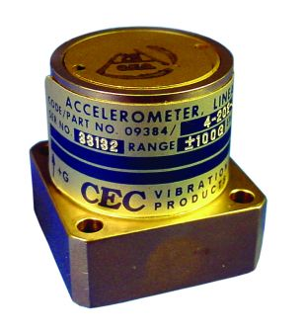

**Fig 4.8- Strain Gauge Accelerometer**

* + 1. **AC Accelerometers**

AC accelerometers, also known as AC-coupled accelerometers, are sensors designed to measure dynamic accelerations and are not sensitive to static accelerations like gravity. These accelerometers use an AC coupling circuit to remove the DC component from the accelerometer output, allowing them to measure only changes in acceleration over time. AC accelerometers are typically used in applications where only dynamic vibrations or movements need to be measured, such as monitoring machine vibrations, structural health monitoring in buildings and bridges, and detecting impacts in automotive crash testing. They offer high sensitivity and accuracy for dynamic measurements and are often preferred for applications where static accelerations are not of interest. However, for applications requiring measurement of both static and dynamic accelerations, DC accelerometers or MEMS accelerometers with a DC response are more suitable.

* + - 1. **Piezo-Electric Accelerometer**

AC accelerometers, also known as AC-coupled accelerometers, are sensors designed to measure dynamic accelerations and are not sensitive to static accelerations like gravity. These accelerometers use an AC coupling circuit to remove the DC component from the accelerometer output, allowing them to measure only changes in acceleration over time. AC accelerometers are typically used in applications where only dynamic vibrations or movements need to be measured, such as monitoring machine vibrations, structural health monitoring in buildings and bridges, and detecting impacts in automotive crash testing. They offer high sensitivity and accuracy for dynamic measurements and are often preferred for applications where static accelerations are not of interest. However, for applications requiring measurement of both static and dynamic accelerations, DC accelerometers or MEMS accelerometers with a DC response are more suitable.

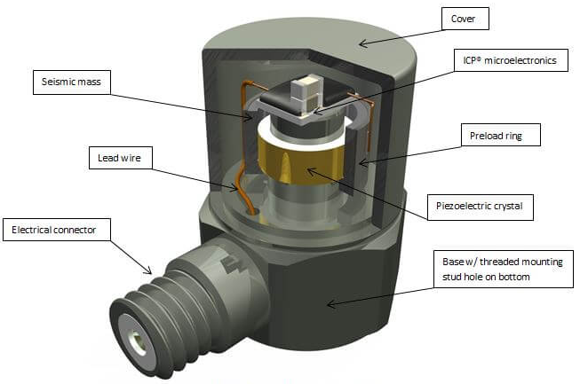

**Fig 4.9- Piezo-electric Accelerometer**

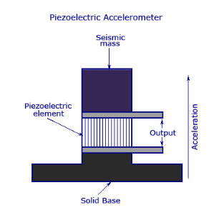

**Fig 4.10- Piezo-electric Accelerometer diagram**

**Chapter-5**

* 1. **Overview of GUI**

The MATLAB GUI designed for calculating G levels (acceleration levels) and Power Spectral Density (PSD) from vibration data provides a user-friendly interface for performing vibration analysis. Here's an overview of the GUI's key components and functionalities:

1. **File Loading Section**:
   * **Load Data Button**: Allows users to import vibration data from external files (e.g.,.xlsx, .mat files).
   * **File Information Display**: Shows the loaded file name, sampling frequency, and other relevant information.
2. **Data Visualization Section**:
   * **Time-Domain Plot**: Displays the raw vibration signal in the time domain, showing the amplitude of the vibration signal over time.
3. **Processing and Analysis Section**:
   * **Calculate G Levels Button**: Computes the G levels (acceleration levels) from the loaded vibration data, typically by applying appropriate filters and processing techniques. Also entering the sensitivity of sensors.
   * **G Levels Display**: Shows the calculated G levels and provides information about the maximum and minimum G levels observed.
4. **Power Spectral Density (PSD) Section**:
   * **Calculate PSD Button**: Estimates the Power Spectral Density (PSD) of the vibration signal, which represents the distribution of power across different frequencies.
   * **PSD Plot**: Displays the PSD plot, with frequency on the x-axis and power/frequency (dB/Hz) on the y-axis, providing insights into the frequency content and intensity of the vibration signal.
5. **Export and Save Section**:
   * **Export Data Button**: Allows users to export the calculated G levels and PSD data for further analysis or reporting.
   1. **Design and Layout**

Designing the layout of a GUI in MATLAB involves arranging and customizing various UI components to create an intuitive and user-friendly interface. Here are some key steps and considerations for designing the layout of a GUI using MATLAB's App Designer:

1. Identify UI Components:
   * Determine the necessary UI components based on the functionality of your GUI (e.g., buttons, sliders, axes, labels).
   * Consider the information you want to display, user inputs required, and actions to be performed.
2. Arrange Components:
   * Drag and drop UI components from the Component Library onto the canvas in App Designer.
   * Arrange the components spatially to create a logical flow and visually appealing layout.
   * Use grids and panels to organize and group relatedcomponents.
3. Customize Appearance:
   * Customize the appearance of UI components by adjusting properties such as size, color, font, and alignment.
   * Use icons or images to enhance visual representation and clarity.
   * Ensure consistent styling and formatting throughout the GUI for a cohesive look.
4. Consider User Interaction:
   * Define callbacks for UI components to specify actions triggered by user interactions (e.g., button clicks, slider changes).
   * Implement event handling to update UI elements dynamically based on user inputs or data processing

The design of a GUI in MATLAB for Power Spectral Density (PSD) calculation typically involves creating an intuitive interface with key components such as data loading buttons, parameter input fields for sampling frequency and window type, and buttons to trigger PSD calculation and plot generation. The GUI should include visual elements like time-domain plots for raw data visualization and PSD plots to display the frequency content of the signal. Users should have controls for zooming, panning, and interacting with the graphs, along with options to export calculated PSD data and save plots. Feedback mechanisms such as status messages and data information displays enhance user experience and guide users through the analysis process. Customization options for window types, overlap percentages, and other parameters add flexibility to the PSD calculation process, making the GUI a valuable tool for engineers and researchers conducting spectral analysis and vibration studies. The design of a MATLAB GUI for Power Spectral Density (PSD) calculation involves thoughtful consideration of the user's workflow and analytical needs. The GUI should provide a seamless experience for loading vibration data, specifying input parameters such as sampling frequency and window type, and performing PSD calculations using methods like Welch's method or the Fast Fourier Transform (FFT). Visual elements like time-domain plots help users inspect the raw data, while PSD plots offer insights into frequency characteristics and power distribution. Interactive features such as zooming, panning, and cursor tools enable users to explore specific regions of interest in the PSD plot. Error handling and informative feedback messages ensure users are aware of any issues during data processing. Export options for PSD data and plot saving functionalities allow users to document and share their analysis results easily. Overall, an effective GUI design for PSD calculation in MATLAB streamlines data analysis tasks, enhances user productivity, and promotes a deeper understanding of vibration signals and spectral analysis techniques.

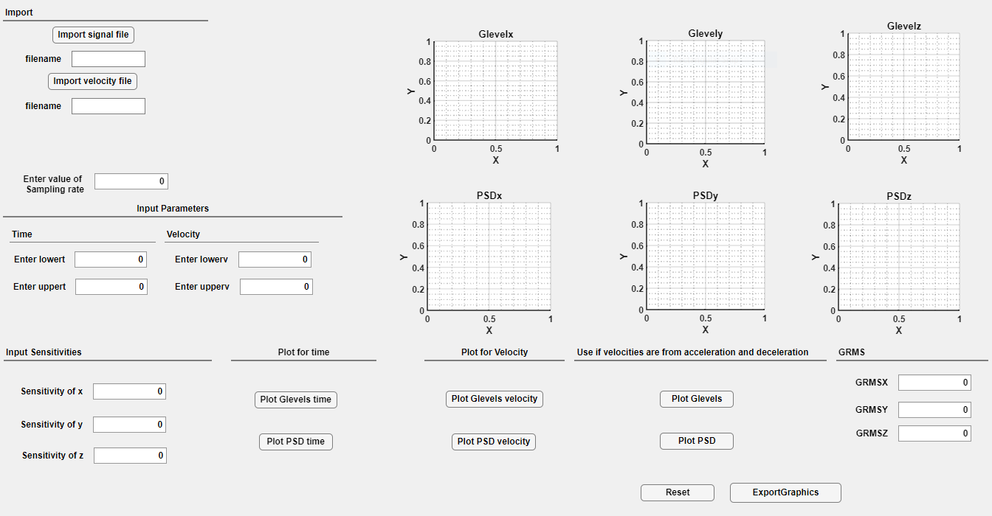

**Fig 5.1- GUI Layout**

**5.3 Key Features and Functionalities**

A GUI designed in MATLAB for Power Spectral Density (PSD) calculation and plotting graphs typically incorporates several key features and functionalities to facilitate efficient data analysis and visualization.

In MATLAB GUI , there are many panels each panel has its own function.

Import panel allows user to import the required data file in which vibration data is stored for performing vibration analysis. Filename Edit field displays the name of imported file.

Input Parameters Panel allows user to input the required time in which they want to plot G-levels and PSD. Enterlowert allows to input the lower value of time and in same way Enteruppert allows to input the upper value of time.

Enter Value of Sampling Rate allows user to input Sampling Rate at which data is obtained.

Input Sensitivities Panel allows user to input the value of sensitivities of each sensor anf for each axis that is for x-axis, y-axis and z-axis.

Buttons are provided for plotting the G-levels as well as PSD , when the button is pressed the callback written is executed and graphs on axis are plotted and they can be further zoomed and values of each point can be calculated just by pressing at that point . If we want to save the graphs in pdf format then click on Exportgraphics button . Also if want to reset the axis then push on Reset button provided.

**Functionalities:**

1. **Data Loading and Extraction**: The code begins by loading data from a specified file using **readtable**, which is a common method for handling structured data like CSV or Excel files. It extracts voltage data (**voltagedatax** , **voltagedatay**, **voltagedataz**) from specific columns in the loaded data table based on the user-entered sampling rate and time range. This step ensures that only the relevant portion of the data is used for analysis, improving efficiency and accuracy in processing large datasets.
2. **G Level Calculation**: After extracting the voltage data, the code calculates G levels (**glevelx**, **glevely**, **glevelz**) for each axis (X, Y, Z). G levels represent the acceleration experienced by the sensor and are computed by dividing the voltage data by the sensitivity values specified in the GUI (**SensitivityofxEditField**, **SensitivityofyEditField**, **SensitivityofzEditField**). This step is crucial for converting raw sensor data into meaningful units of acceleration, which are essential for vibration analysis and engineering applications.
3. **PSD Calculation using Welch's Method**: Next, the code computes the Power Spectral Density (PSD) using Welch's method (**pwelch**). PSD is a frequency-domain representation of a signal's power distribution across different frequencies and is commonly used in vibration analysis to identify dominant frequency components and characterize the signal's frequency content. The code calculates PSD for each axis (X, Y, Z) based on the G level data and the specified sampling rate, window size, and overlap parameters.
4. **Integration and RMS Calculation**: The code integrates the PSD values within the frequency range of 0 to 2000 Hz (**limx**, **limy, limz**) using **trapz**, which is a numerical integration function in MATLAB. Integration helps quantify the total power or energy contained in the signal within the specified frequency band, providing insights into signal intensity. The integrated PSD values are then used to calculate the Root Mean Square (RMS) values (**GRMSXEditField**, **GRMSYEditField**, **GRMSZEditField**) by taking the square root, representing the RMS vibration amplitude for each axis.
5. **Plotting PSD Data**: Finally, the code plots the calculated PSD data on separate log-log axes (**UIAxes4**, **UIAxes5**, **UIAxes6**) using **loglog**. Log-log plots are commonly used in spectral analysis to visualize PSD data, as they allow for better representation of wide frequency ranges and highlight low-amplitude components. Plotting PSD data within the GUI provides users with visual insights into the frequency characteristics of the vibration signal and facilitates data interpretation and analysis.

**Brief Description of Functions Used for Developing GUI**

The code snippet you provided utilizes several functions and methods from MATLAB's extensive library to perform various tasks related to vibration analysis, data processing, and spectral computation. Let's delve into the functions used in the code and their roles within the context of the vibration analysis GUI:

1. **readtable:** The **readtable** function is a powerful tool for reading structured data from files such as CSV or Excel. In this code, **readtable** is used to load data from a file specified by the user in the GUI's **filenameEditField**. The function reads the data into a table format (**T**), making it easier to manipulate and extract specific columns of interest.
2. **pwelch:** **pwelch** is a function used for estimating the Power Spectral Density (PSD) of a signal. In this code, **pwelch** is applied to the G-level data (**glevelx**, **glevely**, **glevelz**) to compute the PSD for each axis (X, Y, Z). The function parameters include the data to be analyzed, the window size (**2048**), overlap (**0** for no overlap), and the sampling rate (**EntervalueofSamplingrateEditField**), which are essential for accurate PSD computation.
3. **loglog:** The **loglog** function is used for creating log-log plots, where both the x-axis and y-axis are logarithmically scaled. In this code, **loglog** is used to plot the calculated PSD data (**pxx_xaxis**, **pxx_yaxis**, **pxx_zaxis**) on separate axes (**UIAxes4**, **UIAxes5**, **UIAxes6**). Log-log plots are commonly used in spectral analysis to visualize PSD data over a wide frequency range, providing a clear representation of signal power across different frequencies.
4. **trapz:** **trapz** is a numerical integration function that computes the integral of a function using the trapezoidal method. In this code, **trapz** is employed to integrate the PSD values (**pxx_xaxis**, **pxx_yaxis**, **pxx_zaxis**) within a specified frequency range (0 to 2000 Hz). Integration is crucial for quantifying the total power or energy contained in the signal within the specified frequency band, which is then used to calculate Root Mean Square (RMS) values (**GRMSXEditField**, **GRMSYEditField**, **GRMSZEditField**

**5.4 MATLAB Code**

classdef mainapp < matlab.apps.AppBase

% Properties that correspond to app components

properties (Access = public)

UIFigure matlab.ui.Figure

GRMSPanel matlab.ui.container.Panel

GRMSZEditField matlab.ui.control.NumericEditField

GRMSZEditFieldLabel matlab.ui.control.Label

GRMSYEditField matlab.ui.control.NumericEditField

GRMSYEditFieldLabel matlab.ui.control.Label

GRMSXEditField matlab.ui.control.NumericEditField

GRMSXEditFieldLabel matlab.ui.control.Label

ResetButton matlab.ui.control.Button

PlotforVelocityPanel matlab.ui.container.Panel

PlotPSDvelocityButton matlab.ui.control.Button

PlotGlevelsvelocityButton matlab.ui.control.Button

PlotfortimePanel matlab.ui.container.Panel

PlotPSDtimeButton matlab.ui.control.Button

PlotGlevelstimeButton matlab.ui.control.Button

ExportGraphicsButton matlab.ui.control.Button

InputParametersPanel matlab.ui.container.Panel

VelocityPanel matlab.ui.container.Panel

EnteruppervEditField matlab.ui.control.NumericEditField

EnteruppervEditFieldLabel matlab.ui.control.Label

EnterlowervEditField matlab.ui.control.NumericEditField

EnterlowervEditFieldLabel matlab.ui.control.Label

TimePanel matlab.ui.container.Panel

EnterlowertEditField matlab.ui.control.NumericEditField

EnterlowertEditFieldLabel matlab.ui.control.Label

EnteruppertEditField matlab.ui.control.NumericEditField

EnteruppertEditFieldLabel matlab.ui.control.Label

UseifvelocitiesarefromaccelerationanddecelerationPanel matlab.ui.container.Panel

PlotPSDButton matlab.ui.control.Button

PlotGlevelsButton matlab.ui.control.Button

InputSensitivitiesPanel matlab.ui.container.Panel

SensitivityofzEditField matlab.ui.control.NumericEditField

SensitivityofzEditFieldLabel matlab.ui.control.Label

SensitivityofyEditField matlab.ui.control.NumericEditField

SensitivityofyEditFieldLabel matlab.ui.control.Label

SensitivityofxEditField matlab.ui.control.NumericEditField

SensitivityofxEditFieldLabel matlab.ui.control.Label

ImportPanel matlab.ui.container.Panel

filenameEditField_2 matlab.ui.control.EditField

filenameEditField_2Label matlab.ui.control.Label

ImportvelocityfileButton matlab.ui.control.Button

filenameEditField matlab.ui.control.EditField

filenameEditFieldLabel matlab.ui.control.Label

ImportsignalfileButton matlab.ui.control.Button

EntervalueofSamplingrateEditField matlab.ui.control.NumericEditField

EntervalueofSamplingrateLabel matlab.ui.control.Label

UIAxes6 matlab.ui.control.UIAxes

UIAxes5 matlab.ui.control.UIAxes

UIAxes4 matlab.ui.control.UIAxes

UIAxes3 matlab.ui.control.UIAxes

UIAxes2 matlab.ui.control.UIAxes

UIAxes matlab.ui.control.UIAxes

end

%

properties (Access = private)

end

methods (Access = public)

end

% Callbacks that handle component events

methods (Access = private)

% Button pushed function: ImportsignalfileButton

function ImportsignalfileButtonPushed(app, event)

[filename,path]=uigetfile();

app.filenameEditField.Value=filename;

end

% Value changed function: SensitivityofxEditField

function SensitivityofxEditFieldValueChanged(app, event)

value = app.SensitivityofxEditField.Value;

end

% Value changed function: EntervalueofSamplingrateEditField

function EntervalueofSamplingrateEditFieldValueChanged(app, event)

value = app.EntervalueofSamplingrateEditField.Value;

end

% Button pushed function: PlotGlevelstimeButton

function PlotGlevelstimeButtonPushed(app, event)

% Glevels calculation for Time domain

T=readtable(app.filenameEditField.Value);

indexl=(((app.EntervalueofSamplingrateEditField.Value)*(app.EnterlowertEditField.Value))+1);

indexu=(((app.EntervalueofSamplingrateEditField.Value)*(app.EnteruppertEditField.Value))+1);

timedata=T.(cell2mat(T.Properties.VariableNames(1)))((indexl):(indexu));

voltagedatax=T.(cell2mat(T.Properties.VariableNames(2)))((indexl):(indexu));

voltagedatay=T.(cell2mat(T.Properties.VariableNames(3)))((indexl):(indexu));

voltagedataz=T.(cell2mat(T.Properties.VariableNames(4)))((indexl):(indexu));

glevelx=voltagedatax./app.SensitivityofxEditField.Value;

glevely=voltagedatay./app.SensitivityofyEditField.Value;

glevelz=voltagedataz./app.SensitivityofzEditField.Value;

plot(app.UIAxes,timedata,glevelx)

plot(app.UIAxes2,timedata,glevely)

plot(app.UIAxes3,timedata,glevelz)

end

% Value changed function: SensitivityofyEditField

function SensitivityofyEditFieldValueChanged(app, event)

value = app.SensitivityofyEditField.Value;

end

% Value changed function: SensitivityofzEditField

function SensitivityofzEditFieldValueChanged(app, event)

value = app.SensitivityofzEditField.Value;

end

% Value changed function: filenameEditField

function filenameEditFieldValueChanged2(app, event)

value = app.filenameEditField.Value;

value = app.filenameEditField.Value;

app.filenameEditField.Value=filename;

figure(app.UIFigure)

end

% Button pushed function: PlotPSDtimeButton

function PlotPSDtimeButtonPushed(app, event)

% Calculation for PSD for Time domain

T=readtable(app.filenameEditField.Value);

indexl=(((app.EntervalueofSamplingrateEditField.Value)*(app.EnterlowertEditField.Value))+1);

indexu=(((app.EntervalueofSamplingrateEditField.Value)*(app.EnteruppertEditField.Value))+1);

voltagedatax=T.(cell2mat(T.Properties.VariableNames(2)))((indexl):(indexu));

voltagedatay=T.(cell2mat(T.Properties.VariableNames(3)))((indexl):(indexu));

voltagedataz=T.(cell2mat(T.Properties.VariableNames(4)))((indexl):(indexu));

glevelx=voltagedatax./app.SensitivityofxEditField.Value;

glevely=voltagedatay./app.SensitivityofyEditField.Value;

glevelz=voltagedataz./app.SensitivityofzEditField.Value;

[pxx_xaxis,f_xaxis] = pwelch( glevelx,2048,0,2048,app.EntervalueofSamplingrateEditField.Value);

loglog(app.UIAxes4,f_xaxis,pxx_xaxis)

limx=(f_xaxis>0)&(f_xaxis<=2000);

X=trapz(f_xaxis(limx),pxx_xaxis(limx));

X=(X)^(1/2);

app.GRMSXEditField.Value=X;

[pxx_yaxis,f_yaxis] = pwelch( glevely,2048,0,2048,app.EntervalueofSamplingrateEditField.Value);

loglog(app.UIAxes5,f_yaxis,pxx_yaxis)

limy=(f_yaxis>0)&(f_yaxis<=2000);

Y=trapz(f_yaxis(limy),pxx_yaxis(limy));

Y=(Y)^(1/2);

app.GRMSYEditField.Value=Y;

[pxx_zaxis,f_zaxis] = pwelch( glevelz,2048,0,2048,app.EntervalueofSamplingrateEditField.Value);

loglog(app.UIAxes6,f_zaxis,pxx_zaxis)

limz=(f_zaxis>0)&(f_zaxis<=2000);

Z=trapz(f_zaxis(limz),pxx_zaxis(limz));

Z=(Z)^(1/2);

app.GRMSZEditField.Value=Z;

end

% Button pushed function: ImportvelocityfileButton

function ImportvelocityfileButtonPushed(app, event)

[filename,path]=uigetfile();

app.filenameEditField_2.Value=filename;

end

% Value changed function: filenameEditField_2

function filenameEditField_2ValueChanged(app, event)

value = app.filenameEditField_2.Value;

app.filenameEditField_2.Value=filename;

figure(app.UIFigure)

end

% Button pushed function: PlotGlevelsvelocityButton

function PlotGlevelsvelocityButtonPushed(app, event)

% Calculation of Glevels when Velocity is given as input

% parameter

A=readtable(app.filenameEditField_2.Value); %velocity file read

n=size(A.(cell2mat(A.Properties.VariableNames(1)))); %no. of rows in velocity file

if (app.EnterlowervEditField.Value<=app.EnteruppervEditField.Value)

% loop for finding the closest value of given lower velocity in velocity file

i=1;

while(i<(n(1)+1)) % loop will run until velocity value becomes greater than given value

if(A.(cell2mat(A.Properties.VariableNames(2)))(i)>=app.EnterlowervEditField.Value)

upper_bound=A.(cell2mat(A.Properties.VariableNames(2)))(i);

lower_bound=A.(cell2mat(A.Properties.VariableNames(2)))(i-1);

break;

end

i=i+1;

end

if(abs(app.EnterlowervEditField.Value-upper_bound)>abs(app.EnterlowervEditField.Value-lower_bound))

app.EnterlowervEditField.Value=lower_bound;

else

app.EnterlowervEditField.Value=upper_bound;

end

% loop for finding the closest value of given upper velocity in velocity file

j=1;

while(j<(n(1)+1))

if(A.(cell2mat(A.Properties.VariableNames(2)))(j)>=app.EnteruppervEditField.Value)

upper_bound2=A.(cell2mat(A.Properties.VariableNames(2)))(j);

lower_bound2=A.(cell2mat(A.Properties.VariableNames(2)))(j-1);

break;

end

j=j+1;

end

if(abs(app.EnteruppervEditField.Value-upper_bound2)>abs(app.EnteruppervEditField.Value-lower_bound2))

app.EnteruppervEditField.Value=lower_bound2;

else

app.EnteruppervEditField.Value=upper_bound2;

end

tolerance=1e-11;

rows=ismembertol(A.(cell2mat(A.Properties.VariableNames(2))),app.EnterlowervEditField.Value,tolerance);

ilv=find(rows==1);

rows1=ismembertol(A.(cell2mat(A.Properties.VariableNames(2))),app.EnteruppervEditField.Value,tolerance);

iuv=find(rows1==1);

y1=A.(cell2mat(A.Properties.VariableNames(1)))(ilv);

y2=A.(cell2mat(A.Properties.VariableNames(1)))(iuv);

T=readtable(app.filenameEditField.Value);

tolerance=1e-10;

v=ismembertol(T.(cell2mat(T.Properties.VariableNames(1))),y1,tolerance);

ilvt=find(v==1);

u=ismembertol(T.(cell2mat(T.Properties.VariableNames(1))),y2,tolerance);

iuvt=find(u==1);

timedatav=T.(cell2mat(T.Properties.VariableNames(1)))((ilvt):(iuvt));

voltagedatavx=T.(cell2mat(T.Properties.VariableNames(2)))((ilvt):(iuvt));

voltagedatavy=T.(cell2mat(T.Properties.VariableNames(3)))((ilvt):(iuvt));

voltagedatavz=T.(cell2mat(T.Properties.VariableNames(4)))((ilvt):(iuvt));

glevelx=voltagedatavx./app.SensitivityofxEditField.Value;

glevely=voltagedatavy./app.SensitivityofyEditField.Value;

glevelz=voltagedatavz./app.SensitivityofzEditField.Value;

velocitydata=A.(cell2mat(A.Properties.VariableNames(2)))((ilv):(iuv));

timedata=A.(cell2mat(A.Properties.VariableNames(1)))((ilv):(iuv));

yyaxis (app.UIAxes,'left')

plot(app.UIAxes,timedatav,glevelx,"Color",[0 0.447 0.7410]);

yyaxis (app.UIAxes,'right')

plot(app.UIAxes,timedata,velocitydata)

yyaxis (app.UIAxes2,'left')

plot(app.UIAxes2,timedatav,glevely,"Color",[0 0.447 0.7410]);

yyaxis (app.UIAxes2,'right')

plot(app.UIAxes2,timedata,velocitydata)

yyaxis (app.UIAxes3,'left')

plot(app.UIAxes3,timedatav,glevelz,"Color",[0 0.447 0.7410]);

yyaxis (app.UIAxes3,'right')

plot(app.UIAxes3,timedata,velocitydata)

else

m=max(A.(cell2mat(A.Properties.VariableNames(2))));

tolerance=1e-15;

ma=ismembertol(A.(cell2mat(A.Properties.VariableNames(2))),m,tolerance);

xm=find(ma==1);

maxdata=A.(cell2mat(A.Properties.VariableNames(2)))((xm):(end));

i=1;

while(i<(n(1)+1))

if(maxdata(i)<=app.EnterlowervEditField.Value)

upper_bound=maxdata(i);

lower_bound=maxdata(i-1);

break;

end

i=i+1;

end

if(abs(app.EnterlowervEditField.Value-upper_bound)>abs(app.EnterlowervEditField.Value-lower_bound))

app.EnterlowervEditField.Value=lower_bound;

else

app.EnterlowervEditField.Value=upper_bound;

end

% for upperv

j=1;

while(j<(n(1)+1))

if(maxdata(j)<=app.EnteruppervEditField.Value)

upper_bound2=maxdata(j);

lower_bound2=maxdata(j-1);

break;

end

j=j+1;

end

if(abs(app.EnteruppervEditField.Value-upper_bound2)>abs(app.EnteruppervEditField.Value-lower_bound2))

app.EnteruppervEditField.Value=lower_bound2;

else

app.EnteruppervEditField.Value=upper_bound2;

end

T=readtable(app.filenameEditField.Value);

idxlv=ismembertol(maxdata,app.EnterlowervEditField.Value,tolerance);

idxlvf=find(idxlv==1);

idxuv=ismembertol(maxdata,app.EnteruppervEditField.Value,tolerance);

idxuvf=find(idxuv==1);

idxlvf=idxlvf+xm-1;

idxuvf=idxuvf+xm-1;

idxlt=A.(cell2mat(A.Properties.VariableNames(1)))(idxlvf);

idxut=A.(cell2mat(A.Properties.VariableNames(1)))(idxuvf);

tolerance1=1e-6;

tl=ismembertol(T.(cell2mat(T.Properties.VariableNames(1))),idxlt,tolerance1);

xlf=find(tl==1);

tu=ismembertol(T.(cell2mat(T.Properties.VariableNames(1))),idxut,tolerance1);

xuf=find(tu==1);

timedata2=T.(cell2mat(T.Properties.VariableNames(1)))((xlf):(xuf));

voltagedatavx2=T.(cell2mat(T.Properties.VariableNames(2)))((xlf):(xuf));

voltagedatavy2=T.(cell2mat(T.Properties.VariableNames(3)))((xlf):(xuf));

voltagedatavz2=T.(cell2mat(T.Properties.VariableNames(4)))((xlf):(xuf));

glevelx2=voltagedatavx2./app.SensitivityofxEditField.Value;

glevely2=voltagedatavy2./app.SensitivityofyEditField.Value;

glevelz2=voltagedatavz2./app.SensitivityofzEditField.Value;

% plot(app.UIAxes,timedata2,voltagedatavx2)

% plot(app.UIAxes2,timedata2,voltagedatavy2)

% plot(app.UIAxes3,timedata2,voltagedatavz2)

velocitydata=A.(cell2mat(A.Properties.VariableNames(2)))((idxlvf):(idxuvf));

timedata=A.(cell2mat(A.Properties.VariableNames(1)))((idxlvf):(idxuvf));

yyaxis (app.UIAxes,'left')

plot(app.UIAxes,timedata2,glevelx2,"Color",[0 0.447 0.7410]);

yyaxis (app.UIAxes,'right')

plot(app.UIAxes,timedata,velocitydata)

yyaxis (app.UIAxes2,'left')

plot(app.UIAxes2,timedata2,glevely2,"Color",[0 0.447 0.7410]);

yyaxis (app.UIAxes2,'right')

plot(app.UIAxes2,timedata,velocitydata)

yyaxis (app.UIAxes3,'left')

plot(app.UIAxes3,timedata2,glevelz2,"Color",[0 0.447 0.7410]);

yyaxis (app.UIAxes3,'right')

plot(app.UIAxes3,timedata,velocitydata)

end

end

% Button pushed function: PlotPSDvelocityButton

function PlotPSDvelocityButtonPushed(app, event)

A=readtable(app.filenameEditField_2.Value);

n=size(A.(cell2mat(A.Properties.VariableNames(1))));

if (app.EnterlowervEditField.Value<=app.EnteruppervEditField.Value)

i=1;

while(i<(n(1)+1))

if(A.(cell2mat(A.Properties.VariableNames(2)))(i)>=app.EnterlowervEditField.Value)

upper_bound=A.(cell2mat(A.Properties.VariableNames(2)))(i);

lower_bound=A.(cell2mat(A.Properties.VariableNames(2)))(i-1);

break;

end

i=i+1;

end

if(abs(app.EnterlowervEditField.Value-upper_bound)>abs(app.EnterlowervEditField.Value-lower_bound))

app.EnterlowervEditField.Value=lower_bound;

else

app.EnterlowervEditField.Value=upper_bound;

end

% for upperv

j=1;

while(j<(n(1)+1))

if(A.(cell2mat(A.Properties.VariableNames(2)))(j)>=app.EnteruppervEditField.Value)

upper_bound2=A.(cell2mat(A.Properties.VariableNames(2)))(j);

lower_bound2=A.(cell2mat(A.Properties.VariableNames(2)))(j-1);

break;

end

j=j+1;

end

if(abs(app.EnteruppervEditField.Value-upper_bound2)>abs(app.EnteruppervEditField.Value-lower_bound2))

app.EnteruppervEditField.Value=lower_bound2;

else

app.EnteruppervEditField.Value=upper_bound2;

end

% rows=A.v==app.Currentlowerv;

% if (app.Currentlowerv<app.Currentupperv)

tolerance=1e-11;

rows=ismembertol(A.(cell2mat(A.Properties.VariableNames(2))),app.EnterlowervEditField.Value,tolerance);

ilv=find(rows==1);

rows1=ismembertol(A.(cell2mat(A.Properties.VariableNames(2))),app.EnteruppervEditField.Value,tolerance);

iuv=find(rows1==1);

% new

y1=A.(cell2mat(A.Properties.VariableNames(1)))(ilv);

y2=A.(cell2mat(A.Properties.VariableNames(1)))(iuv);

T=readtable(app.filenameEditField.Value);

tolerance=1e-10;

v=ismembertol(T.(cell2mat(T.Properties.VariableNames(1))),y1,tolerance);

ilvt=find(v==1);

u=ismembertol(T.(cell2mat(T.Properties.VariableNames(1))),y2,tolerance);

iuvt=find(u==1);

timedatav=T.(cell2mat(T.Properties.VariableNames(1)))((ilvt):(iuvt));

voltagedatavx=T.(cell2mat(T.Properties.VariableNames(2)))((ilvt):(iuvt));

voltagedatavy=T.(cell2mat(T.Properties.VariableNames(3)))((ilvt):(iuvt));

voltagedatavz=T.(cell2mat(T.Properties.VariableNames(4)))((ilvt):(iuvt));

glevelx=voltagedatavx./app.SensitivityofxEditField.Value;

glevely=voltagedatavy./app.SensitivityofyEditField.Value;

glevelz=voltagedatavz./app.SensitivityofzEditField.Value;

[pxx_xaxis,f_xaxis] = pwelch( glevelx,2048,0,2048,app.EntervalueofSamplingrateEditField.Value);

loglog(app.UIAxes4,f_xaxis,pxx_xaxis)

limx=(f_xaxis>0)&(f_xaxis<=2000);

X=trapz(f_xaxis(limx),pxx_xaxis(limx));

X=(X)^(1/2);

app.GRMSXEditField.Value=X;

[pxx_yaxis,f_yaxis] = pwelch( glevely,2048,0,2048,app.EntervalueofSamplingrateEditField.Value);

loglog(app.UIAxes5,f_yaxis,pxx_yaxis)

limy=(f_yaxis>0)&(f_yaxis<=2000);

Y=trapz(f_yaxis(limy),pxx_yaxis(limy));

Y=Y^(1/2);

app.GRMSYEditField.Value=Y;

[pxx_zaxis,f_zaxis] = pwelch( glevelz,2048,0,2048,app.EntervalueofSamplingrateEditField.Value);

loglog(app.UIAxes6,f_zaxis,pxx_zaxis)

limz=(f_zaxis>0)&(f_zaxis<=2000);

Z=trapz(f_zaxis(limz),pxx_zaxis(limz));

Z=Z^(1/2);

app.GRMSZEditField.Value=Z;

else

m=max(A.(cell2mat(A.Properties.VariableNames(2))));

tolerance=1e-15;

ma=ismembertol(A.(cell2mat(A.Properties.VariableNames(2))),m,tolerance);

xm=find(ma==1);

maxdata=A.(cell2mat(A.Properties.VariableNames(2)))((xm):(end));

i=1;

while(i<(n(1)+1))

if(maxdata(i)<=app.EnterlowervEditField.Value)

upper_bound=maxdata(i);

lower_bound=maxdata(i-1);

break;

end

i=i+1;

end

if(abs(app.EnterlowervEditField.Value-upper_bound)>abs(app.EnterlowervEditField.Value-lower_bound))

app.EnterlowervEditField.Value=lower_bound;

else

app.EnterlowervEditField.Value=upper_bound;

end

% for upperv

j=1;

while(j<(n(1)+1))

if(maxdata(j)<=app.EnteruppervEditField.Value)

upper_bound2=maxdata(j);

lower_bound2=maxdata(j-1);

break;

end

j=j+1;

end

if(abs(app.EnteruppervEditField.Value-upper_bound2)>abs(app.EnteruppervEditField.Value-lower_bound2))

app.EnteruppervEditField.Value=lower_bound2;

else

app.EnteruppervEditField.Value=upper_bound2;

end

T=readtable(app.filenameEditField.Value);

idxlv=ismembertol(maxdata,app.EnterlowervEditField.Value,tolerance);

idxlvf=find(idxlv==1);

idxuv=ismembertol(maxdata,app.EnteruppervEditField.Value,tolerance);

idxuvf=find(idxuv==1);

idxlvf=idxlvf+xm-1;

idxuvf=idxuvf+xm-1;

idxlt=A.(cell2mat(A.Properties.VariableNames(1)))(idxlvf);

idxut=A.(cell2mat(A.Properties.VariableNames(1)))(idxuvf);

tolerance1=1e-6;

tl=ismembertol(T.(cell2mat(T.Properties.VariableNames(1))),idxlt,tolerance1);

xlf=find(tl==1);

tu=ismembertol(T.(cell2mat(T.Properties.VariableNames(1))),idxut,tolerance1);

xuf=find(tu==1);

timedata2=T.(cell2mat(T.Properties.VariableNames(1)))((xlf):(xuf));

voltagedatavx=T.(cell2mat(T.Properties.VariableNames(2)))((xlf):(xuf));

voltagedatavy=T.(cell2mat(T.Properties.VariableNames(3)))((xlf):(xuf));

voltagedatavz=T.(cell2mat(T.Properties.VariableNames(4)))((xlf):(xuf));

glevelx=voltagedatavx./app.SensitivityofxEditField.Value;

glevely=voltagedatavy./app.SensitivityofyEditField.Value;

glevelz=voltagedatavz./app.SensitivityofzEditField.Value;

[pxx_xaxis,f_xaxis] = pwelch( glevelx,2048,0,2048,app.EntervalueofSamplingrateEditField.Value);

loglog(app.UIAxes4,f_xaxis,pxx_xaxis)

limx=(f_xaxis>0)&(f_xaxis<=2000);

X=trapz(f_xaxis(limx),pxx_xaxis(limx));

X=(X)^(1/2);

app.GRMSXEditField.Value=X;

[pxx_yaxis,f_yaxis] = pwelch( glevely,2048,0,2048,app.EntervalueofSamplingrateEditField.Value);

loglog(app.UIAxes5,f_yaxis,pxx_yaxis)

limy=(f_yaxis>0)&(f_yaxis<=2000);

Y=trapz(f_yaxis(limy),pxx_yaxis(limy));

Y=(Y)^(1/2);

app.GRMSYEditField.Value=Y;

[pxx_zaxis,f_zaxis] = pwelch( glevelz,2048,0,2048,app.EntervalueofSamplingrateEditField.Value);

loglog(app.UIAxes6,f_zaxis,pxx_zaxis)

limz=(f_zaxis>0)&(f_zaxis<=2000);

Z=trapz(f_zaxis(limz),pxx_zaxis(limz));

Z=(Z)^(1/2);

app.GRMSZEditField.Value=Z;

end

end

% Button pushed function: PlotGlevelsButton

function PlotGlevelsButtonPushed(app, event)

A=readtable(app.filenameEditField_2.Value);

B=readtable(app.filenameEditField.Value);

n=size(A.(cell2mat(A.Properties.VariableNames(1))));

i=1;

while(i<(n(1)+1))

if(A.(cell2mat(A.Properties.VariableNames(2)))(i)>=app.EnterlowervEditField.Value)

upper_bound=A.(cell2mat(A.Properties.VariableNames(2)))(i);

lower_bound=A.(cell2mat(A.Properties.VariableNames(2)))(i-1);

break;

end

i=i+1;

end

if(abs(app.EnterlowervEditField.Value-upper_bound)>abs(app.EnterlowervEditField.Value-lower_bound))

app.EnterlowervEditField.Value=lower_bound;

else

app.EnterlowervEditField.Value=upper_bound;

end

tolerance=1e-6;

v=ismembertol(A.(cell2mat(A.Properties.VariableNames(2))),app.EnterlowervEditField.Value,tolerance);

x1=find(v==1);

y1=A.(cell2mat(A.Properties.VariableNames(1)))(x1);

tolerance=1e-6;

v2=ismembertol(B.(cell2mat(B.Properties.VariableNames(1))),y1,tolerance);

x13=find(v2==1);

m=max(A.(cell2mat(A.Properties.VariableNames(2))));

tolerance=1e-6;

ma=ismembertol(A.(cell2mat(A.Properties.VariableNames(2))),m,tolerance);

xm=find(ma==1);

maxdata=A.(cell2mat(A.Properties.VariableNames(2)))((xm):(end));

j=1;

while(j<(n(1)+1))

if(maxdata(j)<=app.EnteruppervEditField.Value)

upper_bound2=maxdata(j);

lower_bound2=maxdata(j-1);

break;

end

j=j+1;

end

if(abs(app.EnteruppervEditField.Value-upper_bound2)>abs(app.EnteruppervEditField.Value-lower_bound2))

app.EnteruppervEditField.Value=lower_bound2;

else

app.EnteruppervEditField.Value=upper_bound2;

end

idxuv=ismembertol(maxdata,app.EnteruppervEditField.Value,tolerance);

idxuvf=find(idxuv==1);

idxuvf=idxuvf+xm-1;

idxt=A.(cell2mat(A.Properties.VariableNames(1)))(idxuvf);

tolerance1=1e-6;

idxtf=ismembertol(B.(cell2mat(B.Properties.VariableNames(1))),idxt,tolerance1);

indexut=find(idxtf==1);

timedatav=B.(cell2mat(B.Properties.VariableNames(1)))((x13):(indexut));

voltagedatavx=B.(cell2mat(B.Properties.VariableNames(2)))((x13):(indexut));

voltagedatavy=B.(cell2mat(B.Properties.VariableNames(3)))((x13):(indexut));

voltagedatavz=B.(cell2mat(B.Properties.VariableNames(4)))((x13):(indexut));

glevelx=voltagedatavx./app.SensitivityofxEditField.Value;

glevely=voltagedatavy./app.SensitivityofyEditField.Value;

glevelz=voltagedatavz./app.SensitivityofzEditField.Value;

velocitydata=A.(cell2mat(A.Properties.VariableNames(2)))((x1):(idxuvf));

timedata=A.(cell2mat(A.Properties.VariableNames(1)))((x1):(idxuvf));

yyaxis (app.UIAxes,'left')

plot(app.UIAxes,timedatav,glevelx,"Color",[0 0.447 0.7410]);

yyaxis (app.UIAxes,'right')

plot(app.UIAxes,timedata,velocitydata)

yyaxis (app.UIAxes2,'left')

plot(app.UIAxes2,timedatav,glevely,"Color",[0 0.447 0.7410]);

yyaxis (app.UIAxes2,'right')

plot(app.UIAxes2,timedata,velocitydata)

yyaxis (app.UIAxes3,'left')

plot(app.UIAxes3,timedatav,glevelz,"Color",[0 0.447 0.7410]);

yyaxis (app.UIAxes3,'right')

plot(app.UIAxes3,timedata,velocitydata)

end

% Button pushed function: PlotPSDButton

function PlotPSDButtonPushed(app, event)

A=readtable(app.filenameEditField_2.Value);

B=readtable(app.filenameEditField.Value);

n=size(A.(cell2mat(A.Properties.VariableNames(1))));

i=1;

while(i<(n(1)+1))

if(A.(cell2mat(A.Properties.VariableNames(2)))(i)>=app.EnterlowervEditField.Value)

upper_bound=A.(cell2mat(A.Properties.VariableNames(2)))(i);

lower_bound=A.(cell2mat(A.Properties.VariableNames(2)))(i-1);

break;

end

i=i+1;

end

if(abs(app.EnterlowervEditField.Value-upper_bound)>abs(app.EnterlowervEditField.Value-lower_bound))

app.EnterlowervEditField.Value=lower_bound;

else

app.EnterlowervEditField.Value=upper_bound;

end

tolerance=1e-6;

v=ismembertol(A.(cell2mat(A.Properties.VariableNames(2))),app.EnterlowervEditField.Value,tolerance);

idxlv=find(v==1);

idxlvf=A.(cell2mat(A.Properties.VariableNames(1)))(idxlv);

tolerance=1e-6;

idxlt=ismembertol(B.(cell2mat(B.Properties.VariableNames(1))),idxlvf,tolerance);

idxltf=find(idxlt==1);

m=max(A.(cell2mat(A.Properties.VariableNames(2))));

tolerance=1e-6;

ma=ismembertol(A.(cell2mat(A.Properties.VariableNames(2))),m,tolerance);

xm=find(ma==1);

maxdata=A.(cell2mat(A.Properties.VariableNames(2)))((xm):(end));

j=1;

while(j<(n(1)+1))

if(maxdata(j)<=app.EnteruppervEditField.Value)

upper_bound2=maxdata(j);

lower_bound2=maxdata(j-1);

break;

end

j=j+1;

end

if(abs(app.EnteruppervEditField.Value-upper_bound2)>abs(app.EnteruppervEditField.Value-lower_bound2))

app.EnteruppervEditField.Value=lower_bound2;

else

app.EnteruppervEditField.Value=upper_bound2;

end

idxuv=ismembertol(maxdata,app.EnteruppervEditField.Value,tolerance);

idxuvf=find(idxuv==1);

idxuvf=idxuvf+xm-1;

idxtt=A.(cell2mat(A.Properties.VariableNames(1)))(idxuvf);

tolerance1=1e-6;

indexut=ismembertol(B.(cell2mat(B.Properties.VariableNames(1))),idxtt,tolerance1);

xlf=find(indexut==1);

timedatav=B.(cell2mat(B.Properties.VariableNames(1)))((idxltf):(xlf));

voltagedatavx=B.(cell2mat(B.Properties.VariableNames(2)))((idxltf):(xlf));

voltagedatavy=B.(cell2mat(B.Properties.VariableNames(3)))((idxltf):(xlf));

voltagedatavz=B.(cell2mat(B.Properties.VariableNames(4)))((idxltf):(xlf));

glevelx=voltagedatavx./app.SensitivityofxEditField.Value;

glevely=voltagedatavy./app.SensitivityofyEditField.Value;

glevelz=voltagedatavz./app.SensitivityofzEditField.Value;

[pxx_xaxis,f_xaxis] = pwelch( glevelx,2048,0,2048,app.EntervalueofSamplingrateEditField.Value);

loglog(app.UIAxes4,f_xaxis,pxx_xaxis)

limx=(f_xaxis>0)&(f_xaxis<=2000);

X=trapz(f_xaxis(limx),pxx_xaxis(limx));

X=(X)^(1/2);

app.GRMSXEditField.Value=X;

[pxx_yaxis,f_yaxis] = pwelch( glevely,2048,0,2048,app.EntervalueofSamplingrateEditField.Value);

loglog(app.UIAxes5,f_yaxis,pxx_yaxis)

limy=(f_yaxis>0)&(f_yaxis<=2000);

Y=trapz(f_yaxis(limy),pxx_yaxis(limy));

Y=(Y)^(1/2);

app.GRMSYEditField.Value=Y;

[pxx_zaxis,f_zaxis] = pwelch( glevelz,2048,0,2048,app.EntervalueofSamplingrateEditField.Value);

loglog(app.UIAxes6,f_zaxis,pxx_zaxis)

limz=(f_zaxis>0)&(f_zaxis<=2000);

Z=trapz(f_zaxis(limz),pxx_zaxis(limz));

Z=(Z)^(1/2);

app.GRMSZEditField.Value=Z;

end

% Button pushed function: ExportGraphicsButton

function ExportGraphicsButtonPushed(app, event)

exportgraphics(app.UIAxes,"plot.pdf","Append",true);

exportgraphics(app.UIAxes2,"plot.pdf","Append",true);

exportgraphics(app.UIAxes3,"plot.pdf","Append",true);

exportgraphics(app.UIAxes4,"plot.pdf","Append",true);

exportgraphics(app.UIAxes5,"plot.pdf","Append",true);

exportgraphics(app.UIAxes6,"plot.pdf","Append",true);

end

% Button pushed function: ResetButton

function ResetButtonPushed(app, event)

cla(app.UIAxes)

cla(app.UIAxes2)

cla(app.UIAxes3)

cla(app.UIAxes4)

cla(app.UIAxes5)

cla(app.UIAxes6)

end

% Button down function: UIAxes2

function UIAxes2ButtonDown(app, event)

app.UIAxes.Title=app.GRMSXEditField.Value;

end

% Value changed function: EnterlowertEditField

function EnterlowertEditFieldValueChanged(app, event)

value = app.EnterlowertEditField.Value;

end

% Value changed function: EnteruppertEditField

function EnteruppertEditFieldValueChanged(app, event)

value = app.EnteruppertEditField.Value;

end

% Value changed function: EnterlowervEditField

function EnterlowervEditFieldValueChanged(app, event)

value = app.EnterlowervEditField.Value;

end

% Value changed function: EnteruppervEditField

function EnteruppervEditFieldValueChanged(app, event)

value = app.EnteruppervEditField.Value;

**Chapter-6**

**6.1 Plotting G-levels**

**6.1.1 Data Preprocessing in MATLAB**

Data preprocessing in MATLAB involves several steps to ensure the data is correctly formatted, cleaned, and prepared for analysis. For the given code snippet, the data preprocessing steps include reading the data from a file, extracting specific columns, and converting the voltage data to G levels. Here is a detailed explanation of each step:

1. **Reading the Data**: The first step is to read the data from a file into a table format using the readtable function. This function handles various file formats such as CSV, Excel, and text files.

**T = readtable(app.filenameEditField.Value);**

1. **Index Calculation**: Next, the code calculates the indices for the time range specified by the user. The indices are determined based on the sampling rate and the lower and upper time limits provided in the GUI.

**indexl = (((app.EntervalueofSamplingrateEditField.Value) * (app.EnterlowertEditField.Value)) + 1);**

**indexu = (((app.EntervalueofSamplingrateEditField.Value) * (app.EnteruppertEditField.Value)) + 1);**

1. **Data Extraction**: The code then extracts the time data and the corresponding voltage data for each axis (X, Y, Z) based on the calculated indices.

**timedata = T.(cell2mat(T.Properties.VariableNames(1)))((indexl):(indexu));**

**voltagedatax = T.(cell2mat(T.Properties.VariableNames(2)))((indexl):(indexu));**

**voltagedatay = T.(cell2mat(T.Properties.VariableNames(3)))((indexl):(indexu));**

**voltagedataz = T.(cell2mat(T.Properties.VariableNames(4)))((indexl):(indexu));**

1. **Conversion to G Levels**: The extracted voltage data is then converted to G levels by dividing by the sensitivity values specified in the GUI. G levels represent acceleration and are essential for vibration analysis**.**

**glevelx = voltagedatax ./ app.SensitivityofxEditField.Value;**

**glevely = voltagedatay ./ app.SensitivityofyEditField.Value;**

**glevelz = voltagedataz ./ app.SensitivityofzEditField.Value;**

These lines convert the voltage data to G levels for each axis (X, Y, Z) using the sensitivity values provided by the user.

1. **Plotting the Data**: Finally, the code plots the G level data against the time data for each axis in separate axes within the GUI.

**plot(app.UIAxes, timedata, glevelx)**

**plot(app.UIAxes2, timedata, glevely)**

**plot(app.UIAxes3, timedata, glevelz)**

**6.1.2 Plotting techniques in MATLAB**

The provided MATLAB code snippet involves plotting G-levels against time data using basic line plots within a GUI application. The code reads data from a file, calculates the appropriate indices based on the user-specified sampling rate and time range, extracts the relevant time and voltage data, and converts the voltage data into G-levels using user-defined sensitivity values. The G-level data for each axis (X, Y, Z) is then plotted on separate axes within the GUI using the plot function. To enhance these plots for better visualization and analysis, several techniques can be employed. Adding titles, axis labels, and legends provides context to the plots. Customizing line styles and colors helps differentiate between the different axes. Enabling grid lines improves readability, while adding zoom and pan controls allows users to interact with the plots. Additionally, annotations can highlight significant points or events. These enhancements make the plots more user-friendly, informative, and visually appealing, thereby improving the overall user experience of the MATLAB GUI application.

**plot(app.UIAxes, timedata, glevelx)**

**plot(app.UIAxes2, timedata, glevely)**

**plot(app.UIAxes3, timedata, glevelz)**

This creates simple line plots which are straightforward and useful for observing trends and changes over time.

Basic plotting techniques in MATLAB for G-levels involve straightforward methods to visualize data over time, making it easier to interpret and analyze. The most fundamental approach is the line plot, which graphs G-levels against time to show trends and fluctuations. Using the **plot** function, you can create a clear, continuous line that connects data points, and enhance readability by adding titles, axis labels, and grid lines. Another basic technique is the scatter plot, which represents individual data points without connecting lines, useful for highlighting the distribution and density of G-level data. In scenarios involving multiple datasets, such as G-levels along different axes (X, Y, Z), the **subplot** function allows for organizing multiple plots within a single figure, making comparisons easier. Customizing line styles and colors within these plots helps differentiate between datasets, while grid lines and legends improve clarity. These basic techniques provide a solid foundation for visualizing G-level data in MATLAB, ensuring the plots are informative and easy to understand.

**6.1.3 Interpretation of G-levels Plots**

Interpreting G-level plots in MATLAB involves analyzing the plotted data to understand the characteristics and behavior of the vibrations experienced by the system. Here’s a detailed guide to interpreting these plots:

Identifying Peak G-levels

In G-level plots, the peaks represent the maximum accelerationexperienced by the system at various points in time. High peaks might indicate significant vibration events, such as hitting a bump or an impact. Identifying and analyzing these peaks is crucial for understanding the stress and strain on the system.

Frequency and Duration

The frequency of peaks and troughs in the G-level plot gives insight into the periodicity of the vibrations. Regular, periodic peaks might indicate consistent oscillatory motion, whereas irregular peaks could suggest sporadic impacts or variable terrain. The duration of high G-level events can also indicate how long the system is subjected to high stress, which is important for assessing fatigue and wear.

Axis Comparisons

When plotting G-levels for different axes (X, Y, Z), comparing these plots can provide information on the directionality of the vibrations. For example, higher G-levels on the Z-axis might indicate vertical motion, such as bumps or dips in the road, whereas higher G-levels on the X or Y axes could indicate lateral or longitudinal forces.

Overall G-level Trends

Analyzing the overall trend in the G-level data helps in understanding the general behavior of the system. For instance, an increasing trend in G-levels might suggest a system that is accelerating or experiencing increasing forces over time. Conversely, a decreasing trend might indicate deceleration or stabilization.

Noise and Signal Analysis

Noise in the G-level plot can obscure significant vibration events. Identifying and differentiating between noise and actual signal data is crucial. Techniques such as filtering or using statistical methods to smooth the data can help in better visualization and interpretation.

Root Mean Square (RMS) G-levels

RMS G-levels provide a measure of the energycontent of the vibrations. Higher RMS values indicate more intense vibrations**,** which might lead to greater wear and tear on the system. Comparing RMS values across different axes can also give a sense of the overall vibrational energy experienced by the system in different directions.

Example Interpretation

Consider a plot where the G-levels on the Z-axis show frequent, high peaks compared to the X and Y axes. This might indicate that the primary source of vibration is vertical, possibly due to uneven terrain. If these peaks are periodic, it suggests a regular pattern, such as a repeated bump or a specific type of surface irregularity. If the peaks are sporadic, it might indicate occasional impacts or obstacles.

If the overall trend of the G-levels is increasing, it might suggest that the vehicle is encountering progressively rougher terrain or increasing speed. Conversely, a decreasing trend could suggest a transition to smoother terrain or deceleration.

**6.2 Power Spectral Densiy (PSD) Analysis**

**6.2.1 PSD Calculation Methods in MATLAB**

Power Spectral Density (PSD) calculation in MATLAB can be performed using various methods, each with its unique advantages and applications. Here are the primary methods:

* + 1. **FFT(Fast Fourier Transform)- based Method**

The Fast Fourier Transform (FFT) is a fundamental tool for computing the PSD. By transforming the time-domain signal into the frequency domain, the FFT reveals the signal's frequency components. In MATLAB, the fft function is used to perform this transformation. To calculate the PSD, the squared magnitude of the FFT is divided by the length of the signal and then averaged over multiple segments if necessary. This method provides a detailed frequency representation but can be affected by spectral leakage, which can be mitigated using windowing techniques like Hamming or Hanning windows. The Fast Fourier Transform (FFT) method for calculating the Power Spectral Density (PSD) in MATLAB involves several detailed steps to transform a time-domain signal into its frequency-domain representation and compute the PSD. Initially, you start with a time-domain signal, 𝑥(𝑡)*x*(*t*), sampled at a specific rate 𝑓𝑠*fs*​. This signal may be acquired from various sources like sensors or generated synthetically. Pre-processing is crucial and includes removing any DC offset, applying a window function to the signal to minimize spectral leakage, and ensuring the signal length is appropriate for FFT computation. Window functions such as Hamming or Hanning are applied to reduce discontinuities at the edges of the sampled signal, which helps in minimizing spectral leakage. This can be done in MATLAB using the **hamming** function, followed by element-wise multiplication of the signal with the window. The FFT is then computed on the windowed signal using MATLAB’s **fft** function, which converts the time-domain signal into the frequency domain. The FFT result, which contains complex numbers representing both magnitude and phase information, is then used to calculate the two-sided spectrum by taking the magnitude squared of the FFT results and normalizing it. Since the PSD for a real-valued signal is symmetric, only the first half of the FFT results are required. The single-sided spectrum is obtained by taking the first half of the FFT results and doubling the values (except for the DC and Nyquist frequencies) to account for the discarded half. A frequency axis corresponding to the single-sided spectrum is created, which spans from 0 to the Nyquist frequency (half the sampling rate). Finally, the PSD is plotted using MATLAB’s plotting functions, typically on a logarithmic scale to display the power per frequency in decibels per Hertz (dB/Hz). An example code snippet illustrates this process, starting from defining the sampling frequency and time vector, creating an example signal, applying a window, computing the FFT, calculating the two-sided spectrum, converting to a single-sided spectrum, creating the frequency axis, and plotting the PSD. This detailed explanation provides a comprehensive understanding of the FFT method for PSD calculation in MATLAB, including the necessary pre-processing, FFT computation, spectrum adjustment, and visualization steps.

**2.** **Welch’s Method**

Welch's method improves upon the FFT by reducing noise and spectral leakage. It involves dividing the time-domain signal into overlapping segments, applying a window function to each segment, computing the FFT of each segment, and then averaging the squared magnitudes of these FFTs. MATLAB’s pwelch function simplifies this process, allowing users to specify segment length, overlap, and window type. This method provides a smoother and more reliable estimate of the PSD, especially for non-stationary signals. The Welch method for calculating Power Spectral Density (PSD) in MATLAB is a widely used approach that reduces noise in the PSD estimate by averaging the results of multiple Fast Fourier Transform (FFT) calculations. This method involves dividing the time-domain signal into overlapping segments, applying a window function to each segment, computing the FFT of each segment, and then averaging the squared magnitudes of these FFTs. Specifically, the signal is split into several overlapping segments to ensure that each data point is included in multiple segments, which helps in smoothing the resulting PSD. A window function, such as a Hamming or Hanning window, is applied to each segment to minimize spectral leakage by reducing discontinuities at the segment boundaries. MATLAB's **pwelch** function simplifies this process by automating these steps: it computes the FFT of each windowed segment, squares the magnitudes, and then averages these values to produce the PSD estimate. The function can also handle the overlap and windowing parameters, providing a flexible and efficient means to compute the PSD. The result is a smoothed PSD estimate that is more robust to noise compared to a single FFT calculation. This method is particularly useful for signals with noise, as it enhances the signal-to-noise ratio in the PSD estimate. By averaging the squared magnitudes of the FFTs, the Welch method reduces the variance of the PSD estimate, leading to a more stable and reliable frequency-domain representation of the signal. The **pwelch** function in MATLAB requires inputs such as the signal, window length, overlap, and the number of FFT points. It returns the PSD and the corresponding frequency vector, which can be easily plotted to visualize the power distribution across different frequencies. This detailed approach makes the Welch method a powerful tool for frequency analysis in noisy environments.

The Welch method for calculating Power Spectral Density (PSD) in MATLAB offers a robust approach to frequency analysis, especially in scenarios with noisy or non-stationary signals. It improves upon the standard FFT method by incorporating several key enhancements.

**Overlapping Segments:**

Instead of analyzing the entire signal in one go, the Welch method divides it into overlapping segments. This overlap ensures that each data point contributes to multiple segments, providing better frequency resolution and reducing artifacts introduced by abrupt transitions at segment boundaries.

**Windowing:**

A crucial step in the Welch method is the application of window functions to each segment before computing the FFT. Popular window functions like Hamming, Hanning, or Kaiser-Bessel help mitigate spectral leakage caused by sharp transitions in the time-domain signal. These windows taper the edges of each segment, smoothing out discontinuities and reducing noise in the frequency domain.

**Averaging Spectra:**

After windowing and FFT calculation for each segment, the Welch method averages the squared magnitudes of the FFTs across segments. This averaging process improves the signal-to-noise ratio, effectively suppressing noise and enhancing the visibility of underlying frequency components.

**Control Over Parameters:**

MATLAB's **pwelch** function, which implements the Welch method, allows users to control key parameters such as window length, overlap, and number of FFT points. This flexibility enables fine-tuning of the PSD estimation process according to the characteristics of the signal and the desired level of frequency resolution.

1. **Periodogram Method**

The periodogram is the simplest method for estimating the PSD, involving direct computation of the squared magnitude of the FFT of the signal. In MATLAB, the **periodogram** function can be used to compute this estimate. While straightforward, the periodogram is susceptible to high variance and spectral leakage, making it less suitable for noisy or non-stationary signals without additional processing or averaging. The periodogram method for calculating Power Spectral Density (PSD) in MATLAB is a straightforward yet widely used approach that directly computes the squared magnitude of the Fast Fourier Transform (FFT) of the time-domain signal. While simpler compared to methods like Welch's method, the periodogram method is effective for stationary signals with relatively high signal-to-noise ratios. The periodogram method directly provides the PSD estimate without additional smoothing or averaging, making it suitable for scenarios where simplicity and computational efficiency are priorities. However, it is important to note that the periodogram method may be sensitive to noise and may exhibit higher variance compared to methods like Welch's method. As a result, it is often preferred for analyzing stationary signals with relatively clean frequency content.

In summary, the periodogram method in MATLAB offers a straightforward and direct approach to PSD estimation by computing the squared magnitude of the FFT of the signal. It is suitable for analyzing stationary signals with moderate to high signal-to-noise ratios and provides a quick and easy way to visualize the frequency content of a signal in the frequency domain.

Top of Form

1. **Multitaper method**

The Multitaper method further enhances spectral estimation by using multiple orthogonal window functions (tapers) to reduce variance. Each taper generates a slightly different estimate of the PSD, and these estimates are then averaged to produce a final PSD with reduced variance and bias. MATLAB's pmtm function implements this method, allowing users to control the number of tapers and their properties. This approach is particularly effective for signals with closely spaced frequency components or those with low signal-to-noise ratios.

The multitaper method for calculating Power Spectral Density (PSD) in MATLAB is a powerful technique that combines multiple tapered windows to estimate the PSD with improved frequency resolution and reduced variance compared to traditional methods like the periodogram. It is particularly effective for analyzing signals with low signal-to-noise ratios or short data records.

The multitaper method in MATLAB is implemented through the **pmtm** function, which stands for "Multitaper Method." This method involves the following steps:

1. **Choose Taper Functions**: Select one or more taper functions (also known as windows) from a set of predefined tapers such as Slepian or DPSS (Discrete Prolate Spheroidal Sequences). Each taper function offers different characteristics in terms of frequency resolution and sidelobe suppression.
2. **Compute the PSD Estimates**: Apply each taper function to the time-domain signal and compute the PSD estimate for each taper independently using the **pmtm** function. This function takes parameters such as the number of tapers, time-bandwidth product, and frequency range of interest.
3. **Combine PSD Estimates**: Combine the PSD estimates from different tapers using a weighted average. The weights are determined based on the properties of the taper functions and are designed to optimize frequency resolution while reducing variance.
4. **Frequency Axis**: Create a frequency axis corresponding to the multitaper PSD estimate.
5. **Plot the PSD**: Visualize the PSD by plotting the multitaper estimate on a logarithmic scale.

The multitaper method offers several advantages over other PSD estimation techniques. It provides improved frequency resolution by using multiple tapers, which capture different aspects of the signal's frequency content. The weighted averaging of PSD estimates from multiple tapers reduces variance and enhances the accuracy of the PSD estimate, especially for short data records or signals with low signal-to-noise ratios.

Additionally, the multitaper method allows for control over parameters such as the number of tapers and time-bandwidth product, providing flexibility in optimizing the trade-off between frequency resolution and variance reduction. It is widely used in various fields such as neuroscience, geophysics, and signal processing for its robustness and accuracy in PSD estimation.

In summary, the multitaper method in MATLAB offers a sophisticated approach to PSD estimation by leveraging multiple tapered windows to improve frequency resolution and reduce variance, making it a valuable tool for analyzing signals with complex frequency content or challenging noise characteristics.

**6.2.2 Plotting PSD in MATLAB**

The MATLAB code is designed to read vibration data from a file, process it to calculate g-levels, and then compute and plot the Power Spectral Density (PSD) for each axis using Welch's method. Here's a detailed explanation of each step in the code:

First, the code reads the data from a specified file using the **readtable** function and assigns it to the variable **T**. It then calculates the indices for the lower and upper bounds based on the sampling rate and time values provided by the user. These indices are used to extract the relevant portions of the voltage data for the x, y, and z axes from the table **T**. The voltage data is then converted to g-levels by dividing it by the sensitivity values for each axis, which are input by the user through the GUI.

Next, the code calculates the PSD for each axis using Welch's method, implemented by the **pwelch** function. Welch's method involves dividing the signal into overlapping segments, applying a window to each segment, computing the periodogram for each segment, and then averaging the results. The parameters for **pwelch** include the data to be analyzed (glevels for each axis), the segment length (2048 samples), overlap between segments (0), the length of the FFT (2048 points), and the sampling rate provided by the user.

After computing the PSD for the x-axis, the code plots the PSD on a logarithmic scale using the **loglog** function, which is appropriate for visualizing wide-ranging frequency data. It then integrates the PSD over the specified frequency range (0 to 2000 Hz) using the **trapz** function to estimate the root mean square (RMS) g-level, which is stored in **app.GRMSXEditField.Value**. This process is repeated for the y and z axes, with the results plotted on their respective axes (**app.UIAxes5** and **app.UIAxes6**) and the RMS g-levels stored in **app.GRMSYEditField.Value** and **app.GRMSZEditField.Value**.

In summary, this MATLAB code provides a comprehensive method to read, process, and analyze vibration data by calculating g-levels and plotting the PSD using Welch's method, offering insights into the frequency characteristics of the vibration data. The RMS values calculated from the PSD plots give a quantifiable measure of the vibration intensity for each axis.

**6.2.3 Interpretation of PSD PlotsTop of Form**

The interpretation of Power Spectral Density (PSD) plots generated by the MATLAB GUI described involves understanding the frequency characteristics of the vibration data recorded from the vehicle. Here's how to interpret these PSD plots:

1. **Frequency Axis**: The x-axis of the PSD plot represents the frequency components of the vibration data, typically measured in Hertz (Hz). This axis shows the range of frequencies present in the vibration signal.
2. **Power Spectral Density (PSD) Axis**: The y-axis of the PSD plot represents the power of the signal at each frequency, typically in units of g²/Hz (where g represents the acceleration due to gravity). This indicates how much power (or variance) of the vibration signal is distributed across different frequency components.
3. **Logarithmic Scale**: The plots use a logarithmic scale (**loglog** function) for both axes, which helps in visualizing a wide range of frequencies and power values. Logarithmic scales are particularly useful for highlighting differences in power at various frequencies, especially when the data spans several orders of magnitude.
4. **Peaks in the PSD Plot**: Peaks in the PSD plot indicate dominant frequency components in the vibration signal. The height of a peak represents the intensity or power of the vibration at that specific frequency. High peaks suggest significant vibration energy at those frequencies, which could be due to specific sources or resonance frequencies of the vehicle components.
5. **Integration of PSD (RMS Calculation)**: The integrated area under the PSD curve within a specific frequency range gives the Root Mean Square (RMS) value of the vibration, which is a measure of the overall vibration energy. In the provided code, this integration is performed over the range from 0 to 2000 Hz, and the square root of the integrated value is calculated to give the RMS g-levels for the x, y, and z axes. These RMS values are displayed in the GUI, providing a quantifiable measure of the vibration intensity.
6. **Frequency Range of Interest**: The selected frequency range (0 to 2000 Hz) encompasses the typical frequencies of interest in vehicle vibration analysis. This range is critical for identifying the significant sources of vibration and assessing the vehicle's dynamic behavior.
7. **Comparing Axes**: By comparing the PSD plots of the x, y, and z axes, one can determine the direction in which the vibrations are most pronounced. For instance, higher PSD values in the x-axis plot compared to the y and z axes would indicate stronger vibrations in the horizontal direction.
8. **Noise and Disturbances**: The presence of noise in the PSD plot can be identified by a broad spectrum of low-power frequencies without distinct peaks. High levels of noise might indicate external disturbances or sensor inaccuracies.

In summary, the PSD plots provide a detailed frequency-domain representation of the vibration data, allowing for the identification of dominant frequencies, overall vibration intensity, and comparison across different axes. These insights are crucial for diagnosing potential issues, understanding vehicle dynamics, and implementing vibration mitigation strategies.

**Chapter-7**

Data was taken for 40 seconds from vibration sensors which were mounyed on wheels of batter operated vehicle at sampling rate of 25000 Hertz. Data was converted to excel sheet.

**Import Data File:**

Required data excel sheet was loaded by pushing the import button . After pushing import button a dialog menu opens , where we browse to required data sheet which loads it in GUI. After that we input the sampling rate which is 25000 hertz.

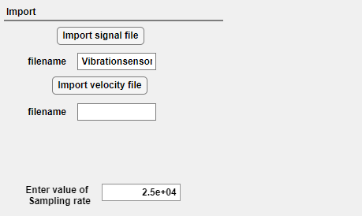

**Fig 7.1**

**Input sensitivities for each axis:**

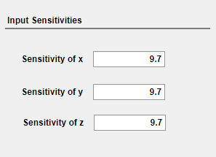

**Fig 7.2**

**7.1 G-levels Graphs**

**G-levels for time 0-40 seconds**

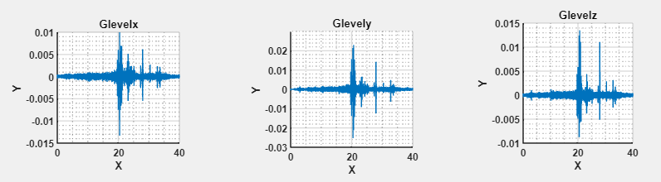

**Fig 7.3**

**G-levels for time 1-10 seconds**

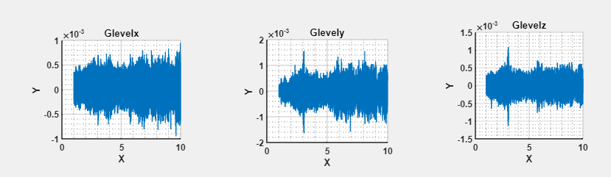

**Fig 7.4**

**G-levels for time 10-18 seconds** 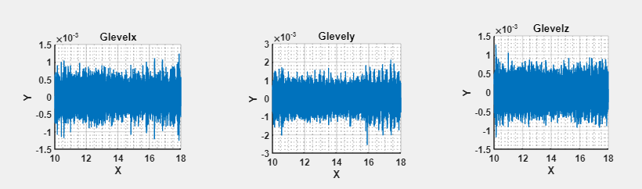

**Fig 7.5**

**G-levels for time 18-25 seconds**

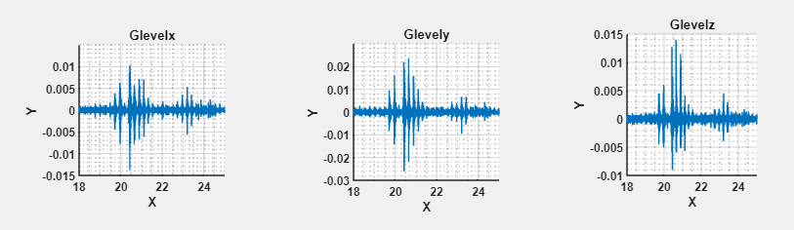

**Fig 7.6**

**7.2 PSD Graphs with their GRMS Values**

**PSD for 0-40 seconds**

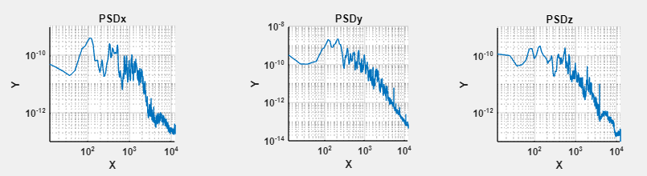

**Fig 7.7**

**GRMS for 0-40 seconds**

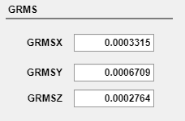

**Fig 7.8**

**PSD for 1-10 seconds**

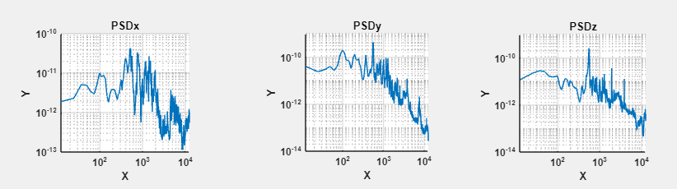

**Fig 7.9**

**GRMS for 1-10 seconds**

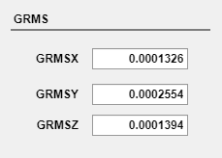

**Fig 7.10**

**PSD for 10-18 seconds**

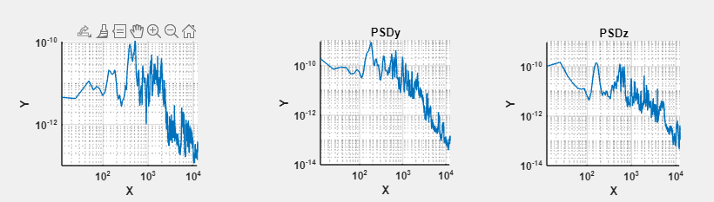

**Fig 7.11**

**GRMS for 10-18 seconds**

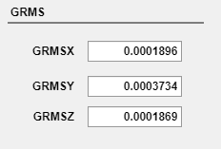

**Fig 7.12**

**PSD for 18-25 seconds**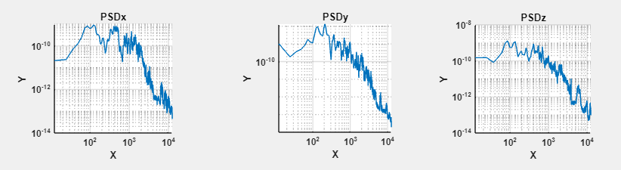

**Fig 7.13**

**GRMS for 18-25 seconds**

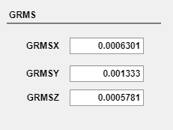

**Fig 7.14**

**Chapter-8**

**8.1 Summary of key findings**

The MATLAB GUI effectively processes and analyzes vibration data from a vehicle, calculating the Power Spectral Density (PSD) for three axes (x, y, and z) and determining the Root Mean Square (RMS) g-levels for each axis. The key steps and findings can be summarized as follows:

1. Data Loading and Preprocessing:
   * The code begins by reading the vibration data from a file using the readtable function.
   * Specific indices are calculated to extract the relevant portion of the data based on the user-defined sampling rate and time range.
   * Voltage data for the x, y, and z axes are extracted and converted to g-levels using the respective sensitivity values provided by the user.
2. PSD Calculation using Welch's Method:
   * The pwelch function is employed to calculate the PSD of the g-level data for each axis.
   * Welch's method is advantageous due to its ability to reduce noise by averaging overlapping segments of the data, providing a smoother and more reliable estimate of the PSD.
3. Plotting the PSD:
   * The PSD plots for the x, y, and z axes are generated using the loglog function, which plots both axes on a logarithmic scale. This helps in visualizing a wide range of frequency components and their corresponding power levels.
   * The frequency range of interest (0 to 2000 Hz) is highlighted, and the plots are displayed on the respective UI axes (UIAxes4, UIAxes5, UIAxes6).
4. RMS g-Level Calculation:
   * The code integrates the area under the PSD curve within the specified frequency range (0 to 2000 Hz) using the trapz function.
   * The square root of the integrated value gives the RMS g-levels for the x, y, and z axes, which are then displayed in the respective UI fields (GRMSXEditField, GRMSYEditField, GRMSZEditField).

Key Findings

1. Frequency Components:
   * The PSD plots reveal the dominant frequency components of the vehicle's vibrations. Peaks in these plots indicate significant vibration energies at specific frequencies, which can be linked to the vehicle's operational characteristics or external factors affecting it.
2. Vibration Intensity:
   * The RMS g-levels calculated from the PSD plots provide a quantitative measure of the overall vibration intensity in each axis. These values are essential for assessing the vehicle's vibration exposure and identifying potential areas for improvement.
3. Directional Analysis:
   * By comparing the PSD plots and RMS g-levels for the x, y, and z axes, one can determine the primary directions of the vehicle's vibrations. This information is crucial for diagnosing issues related to vehicle dynamics and ride comfort.
4. Noise Reduction:
   * The use of Welch's method for PSD calculation helps in reducing the noise in the vibration data, resulting in more accurate and reliable estimates of the PSD and RMS g-levels.

In conclusion, the MATLAB code provides a comprehensive approach to analyzing vehicle vibration data. By calculating and plotting the PSD and RMS g-levels, it offers valuable insights into the frequency characteristics and intensity of the vibrations, aiding in the diagnosis and mitigation of vibration-related issues in vehicles.

**8.2 Recommendations for Future work**

1. Enhanced Data Acquisition:
   * Higher Sampling Rates: Employ higher sampling rates for data acquisition to capture finer details of high-frequency vibrations.
   * Additional Sensors: Use additional sensors to monitor more parameters, such as temperature, pressure, and vehicle speed, to correlate with vibration data for a more comprehensive analysis.
   * Real-Time Data Acquisition: Implement real-time data acquisition and processing to provide immediate feedback and monitoring of vehicle vibrations.
2. Advanced Signal Processing Techniques:
   * Wavelet Transform: Incorporate wavelet transform techniques for analyzing non-stationary signals and capturing transient events in the vibration data.
   * Adaptive Filtering: Use adaptive filtering methods to remove noise and enhance the quality of the vibration signal.
3. Machine Learning and AI:
   * Predictive Maintenance: Develop machine learning models to predict potential failures or maintenance needs based on historical vibration data.
   * Anomaly Detection: Implement AI algorithms for detecting anomalies and unusual patterns in the vibration data, which could indicate underlying issues.
4. Improved Visualization and User Interface:
   * Interactive Plots: Create interactive plots that allow users to zoom in on specific frequency ranges, adjust parameters, and visualize the effects in real-time.
   * Dashboard Integration: Develop a comprehensive dashboard integrating various metrics and visualizations to provide a holistic view of the vehicle's vibration analysis.
5. Comprehensive Analysis and Reporting:
   * Automated Reporting: Implement automated reporting features that generate detailed analysis reports, including PSD plots, RMS g-levels, and identified issues or trends.
   * Comparative Analysis: Enable comparative analysis with baseline or reference data to assess deviations and potential concerns.
6. Validation and Testing:
   * Field Testing: Conduct extensive field testing under various conditions to validate the robustness and reliability of the analysis methods.
   * Benchmarking: Benchmark the results against industry standards and best practices to ensure accuracy and relevance.
7. Integration with Other Systems:
   * Vehicle Management Systems: Integrate the vibration analysis system with broader vehicle management and diagnostics systems to provide a unified platform for vehicle health monitoring.
   * IoT and Cloud Computing: Utilize IoT devices for data collection and cloud computing for storage and advanced data processing, facilitating remote monitoring and analysis.
8. Customization and Scalability:
   * Customizable Algorithms: Develop customizable algorithms and analysis parameters to cater to differenttypes of vehicles and specific user requirements.
   * Scalability: Ensure the system can scale to handle large volumes of data and multiple vehicles simultaneously, maintaining performance and efficiency.

By implementing these recommendations, the system can be significantly enhanced to provide more accurate, comprehensive, and actionable insights into vehicle vibrations, ultimately leading to improved vehicle performance, safety, and comfort.